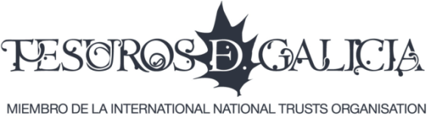

*Tesouros de Galicia* is an association promoting a social movement to aid in the recovery of the heritage of Galicia (Spain) and its cultural identity, and to provide an international platform for the Galician heritage sites, local products and tourism, as a way to strengthen local economy.

In defining "social Movement" it is the responsibility not only of the public administration but of individuals, companies, and cultural entities together, in a social voluntary collaboration of public and private, to form a Social Managerial Responsibility.

*Tesouros de Galicia* is an association not assigned to any commercial or political interests, but invites any individual, company, organization, government or public administration to take part. An open entity made up of people who want to form a structured cultural identity in the service of creating sustainable projects.

To promote individual participation, our organization facilitates volunteering. We offer our own programmes and we are registered as Sending and Hosting Organistion in ERASMUS+ European Voluntary Service, promoting youth mobility and cultural exchange.

*Tesouros de Galicia* collaborates with all Galician Universities as well, so students can run their practices with us (Universidade de A Coruña, Universidade de Santiago de Compostela, Universidade de Vigo and Centro Estudios Superiores Universitarios de Galicia).

Tesouros de Galicia is Member of International National Trusts Organization ([www.intoorg.org](http://www.intoorg.org)), and participates in United Nations Environmental Programme “10YPF” to promote sustainable Production and Consumption in Tourism Industry (<http://sdt.unwto.org/about-10yfp-stp>).

Spanish Governement stated TdG as “Organisation of Public Interest” in 2,016.

 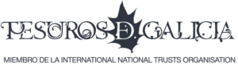 

**Description of our efforts towards a sustainable tourism development**

The key aims of this association are: the development of networks of knowledge and of international exchange, and the cooperation of public and private entities towards the common aim.

*Tesouros de Galicia* is willing to collaborate with international associations, who share a similar philosophy to:

* learn and share from silmilar experiences in the restoration of economic, historic and cultural projects to restore value within their region and their country, in a sustainable and economic way. A program to share experiences between the countries to learn of new projects and new methods of working.
* find ways to attract volunteers to support in the recovery and sustainable management of the historic and natural resources.
* expose the opportunities and values of Galicia at an international level, intensifying " the pleasure of enjoying tourism” with a respectful environmental commitment.
* To involve companies and people in the valuation of the heritage and its promotion, in an economical and sustainable way.
* To transmit a different and innovative image and concern for the Environment, and respect for its historical inheritance (Heritage).
* To create a channel and a focus to facilitate public and private support and good communications, directly and at low cost.
* Turning locals, companies and tourists into protagonists of experience, and ambassadors of its heritage.
* Network for promoting cooperation and transfer of knowledge, in order to share experiences, related to the patrimonial management and cultural identity. Promotion of studies on heritage.
* Promotion of collaborative inter-sectorial initiatives for the joint promotion of the sustainable tourist destinations. Establishing pilot schemes for the joint presentation of services and complementary products.

  