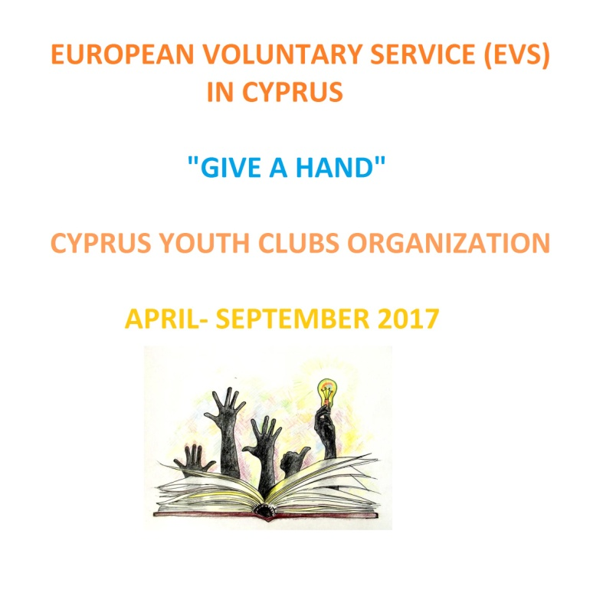 **Erasmus+ Key Action 1. Mobility of Young People**

**Project Title:** “Give a hand”

**Host Organisation:** Cyprus Youth Clubs Organisation

**Main theme of the project:** Through this program, volunteers will have the chance to be involved with young people from urban and rural areas and learn more about our organization and its actions. They are going to be able to offer their knowledge and experience and at the same time improve their personal and professional skills.

**Profile of the participants:** We are looking for creative, multitasking young people who love youth work and volunteerism.

**Group age:** 17- 30

**Number of volunteers:** 4 people.

**Project type:** Erasmus+ Key Action 1. Mobility of Young People. European Voluntary Service.

**Place:** Cyprus

**Dates and duration:** 6 months from 1st of April 2017 to end of September 2017

**Contact person:** Theognosia Petrou

**Address:** Athalassas Av. 169, office. 102, 2025 Stovolos, Nicosia, Cyprus.

**E-mail:** projects@cyprusyouth.org

**Tel.:** +357 22323260 **Fax:** +357 22321979

**Financial Aspects:** Food and accommodation is FREE. A monthly allowance of 110 euros will be given to the volunteers.

**Travel cost:** we will cover the travel cost according to the rules of the programme.

You will need to keep the receipts and the boarding passes.

**Safety & Insurance:** Will also be covered by the organization.

**How to participate:** Organisations have to send us the Partner Information Form and the signed Mandate along with the CV of the Volunteer(s) at projects@cyprusyouth.org with the subject: ‘EVS in Cyprus’.

**Duties:** “Give a hand” is going to be an educational project clearly aiming at disseminating certain skills and awareness about Youth Work among the members of theYouth Clubs. This project is expected to play an important role in the dissemination of the European values among the youth of Cyprus. The volunteers will support local volunteers who are familiar with the specific local needs, such as youth leaders and young volunteers. Volunteers will gather European documentation and will produce informational material. They will also support the European Projects Manager in certain tasks as communication, events, implementation of educational programs, helping youth clubs in partners search, facilitating events, promoting Erasmus+, promoting the EU values, key priorities and opportunities. The volunteers will receive mentoring from the European Projects Manager of KOKEN. At the end of their service they will receive a certificate and recommendation letter(s).

