
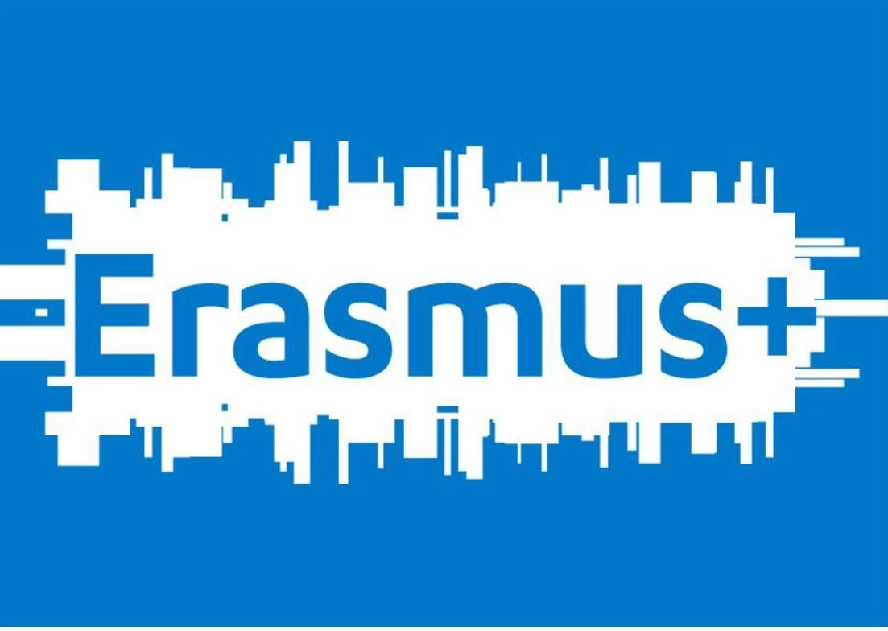

UILDM - EVS VOLUNTEER APPLICATION FORM
Volunteering for Inclusion

First name:
Last name:
Date of birth: | Age: |  | Gender:
Nationality:
Field of studies:
Knowledge of the Italian language (speaking and understanding):

Knowledge of other languages (specify which ones and what level: mother tongue, fluent, good, basic):

When would you like to start your placement:
How long would you like to volunteer:
Which sub-project(s) are you applying for:
Phone number(s): |  | E-mail:
Name and EI Ref. Number of Sending Organisation:
Contact details of Sending Organisation:

- Why would you want to be an EVS volunteer at Sezione Laziale UILDM?

- Why did you choose this specific project?

- Have you ever worked with people with disabilities before (please specify the kind of work, the role, for how long, the kind of disability and the age range of the people of disabilities you were in contact with)?

- What do you expect from this experience? How will you reach your own goals in this experience? And what do you expect from the hosting organisation?

- Sezione Laziale della UILDM Onlus promotes the independence and autonomy of people with disabilities. What is your opinion on this approach?

- How would you describe social inclusion?

- How would you describe diversity?

- How would you describe volunteering?

- What motivates you the most about volunteering for a year in another country?

- What do you think your biggest challenge would be to volunteer for a year in another country?

- List 2 advantages and 2 difficulties that you might have in group work.

- Among the activities that you will participate during the project which ones motivate you the most and which ones motivate you the least; why?

- Which is the key to a healthy conflict management in your opinion?

- What are some of the skills/interest that would assist you in carrying out your project?

- Have you ever learned another language? How? How would you rate your language learning skills?

- What are your others skills/interests (volunteering, hobbies, artistic or IT skills)?

- What kind of competences and skills do you think you will be able to acquire during your experience at UILDM?

- What would you like to do once the EVS experience is over?

- Do you have a driving licence and would you be willing to drive Sezione Laziale UILDM’s cars and vans?

