
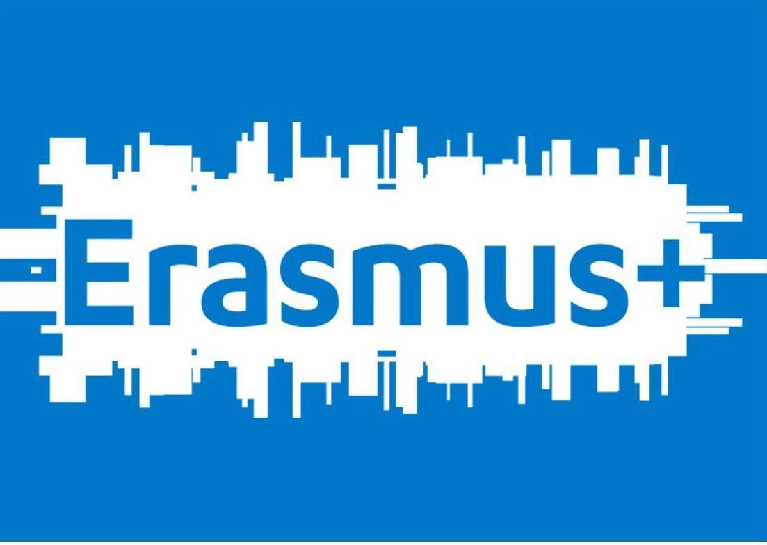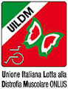

!!!VOLUNTEERS WANTED!!!

Sezione Laziale della UILDM Onlus from Rome, Italy is looking for six volunteers for an EVS placement in our umbrella EVS project “Volunteering for Inclusion”. The placement is for 12 months and will start in April 1st, 2016 and end in March 31st, 2017.
Please read carefully the information here below before you make the application and if you decide that you can collaborate with us, send us the required documents (the list is provided on the last page of this document) to mida@uildmlazio.org no later than August 21st, 2015.

GOOD LUCK!!
Who are we?
Sezione Laziale della U.I.L.D.M. Onlus

UILDM is present in Italy with over 70 branches, which are coordinated by the main offices set in Padua. It is a no-profit organisation whose aims are to foster the social inclusion of people with disabilities and to promote research, prevention and assistance in the field of neuromuscular diseases.
The Sezione Laziale della UILDM Onlus was founded in Rome in 1967. It is the branch with the highest amount of members in the national network, providing social and rehabilitation services to over a thousand users who have neuromuscular diseases in the Lazio region. An important percentage of the staff of the organisation is also people with disabilities.
The organisation has always been active in providing social and rehabilitation services to people with neuromuscular diseases, in developing specific assistance which is provided to people with disabilities for free and in promoting a cultural change that takes into consideration the needs of people with disabilities. Besides medical and scientific services, the Sezione Laziale della UILDM is engaged in raising public awareness concerning a culture of disability, in improving quality of life and promoting equal opportunities for all.
The organisation has a Health Area which offers services of rehabilitation and a Social Area (ASIS). A.S.I.S. (Social Integration Service Area) is the field of UILDM offering support services, guidance and counseling to support Independent Living. The philosophy of our work is to help our users in becoming active protagonists by promoting processes of autonomy and independence. In our services, particular attention is paid to the users aged between 15 and 30 years old as this is the age group going through the self-development process towards autonomy and social integration.
Sezione Laziale della UILDM Onlus has been actively participating in former Youth, Youth in Action programmes and currently Erasmus+ Programme of the European Commission as a sending and hosting EVS organisation.

What is “Volunteering for Inclusion” Project About?

Volunteering for Inclusion is an umbrella project that is composed of 3 sub-projects. This means that all 6 volunteers will work in the same association with the themes of disability and diversity but will have different tasks and roles. The sub-projects are explained here below.
Important: When making your application please indicate which sub-project you are applying for. If you are interested in more than one sub-project then please make a list of priority.

We are looking for:
2 volunteers for “Points of View” sub-project;
2 volunteers for “Integration” sub-project and;
2 volunteer for “Finestra Aperta” sub-project.

Points of View sub-project:

"Points of View" is an educational project that UILDM has been implementing in Rome among middle and high school students for several years now, with the help of our Italian Civil Service volunteers. The project relies on two main tools: an interactive exhibition on disability and group meetings, both facilitated by a group of volunteers. These tools, together with different methodologies that help young people reflect on their prejudices and stereotypes, promote empathy, without denying the differences nor diversity, but supporting the rights of everyone.
The interactive exhibition
The exhibition is shown in schools in the territory and the viewing is facilitated by volunteers. The visitor experiences the role of an active observer, sitting on a wheelchair, s/he moves on architectural barriers relying on a guide that facilitates interaction with various types of images. An experience of being in someone else’s shoes, experiencing trust, listening and observing life stories to encourage the change of own’s perspective from an "external image" to the "identity" of a person.
Group meetings
The students who have seen the exhibition participate in two group meetings facilitated by volunteers. The methodology of the meetings is based on the active involvement of participants; facilitation to give each participant a chance to experiment and to stimulate discussion on restructuring of the concepts and experiences. We use role playing, simulations, storytelling activities, group exercises, using the group as a tool and as an example of the dynamics that underlie our behaviors in relationships, trying to stimulate a positive approach towards others and promote conflict resolution. What will your tasks be during the project?
- Co-management of contacts and relationships with schools and other organizations;
- Revising and developing new additions to the exhibition on disability and diversity;
- Transportation, setting up and dismantling of sets and materials of the exhibition;
- Implementing, supporting, facilitating and mentoring of students during the visit of the exhibition;
- Organising and implementing group meetings;
- Supporting teachers for planning and implementation of tutoring, mentoring, cooperative learning processes;
- Preparation of training materials for training sessions;
- Preparation and distribution of promotional material for the project.

IMPORTANT: For this sub-project we are looking for two volunteers who ALREADY speak some Italian.

Integration sub-project:

The theme of the project is disability and diversity in general. Each volunteer will be coupled up with people with physical disabilities and will be visiting the houses of the people with disabilities and perform “integration” projects. Objectives of each integration project will be defined together with the social workers of the association taking each person’s individual needs into account. With a young kid, the objective might be accompanying him to school or playground; with a teenager can be to go out and walk around Rome together; with an elderly could be doing grocery shopping together etc. The overall idea of these integration projects is:
- to support social inclusion of people with disabilities and offer them different opportunities to socialize;
- to raise awareness of the volunteers on the conditions and social, cultural and physical facilitations and limitations that people with disabilities live;
- to provide a space of cultural interaction among people from different backgrounds (not only different countries, but also different socio-economical situations, different age groups, different ability groups etc.) so that both the volunteers and the locals (mainly the receivers of the services) might benefit from the experience.
Each volunteer will have different cases during the week and will be monitored by a team of professionals including social workers, educators and psychologists working on the same case.

What will your tasks be during the project?

- Implementing integration activities in the houses of people with physical disabilities ;
- Participating in periodic meetings with the integration team to evaluate each case;
- Writing short follow-up reports for the cases;
- Organising and implementing group meetings to promote Erasmus+ and EVS.

Finestra Aperta sub-project:
The theme of the project is disability and diversity. You will be assisting and working together with our association’s Finestra Aperta magazine and FinestrAperta web radio staff. The staff is composed of people with and without disabilities. Finestra Aperta is a quarterly magazine that is distibuted to our clients and other associations for free; FinestrAperta web radio is online on www.finestraperta.org
Besides this main area of work, volunteer will be offering support to different departments of the association based on their interests and skills including:
- Fundraising department: during the year we will organise different fundraising activities for the association and the volunteer will be asked to help in organisation, implementation and evaluation of those activites;
- Social animation department and Youth Group: the association has an informal Youth Group composed of people with mixed abilities. The volunteer will be asked to organize different activities, weekend trips etc. in order to communicate the values and opportunities offered by the Erasmus+ project to their peers.

What will your tasks be during the project?

- Assisting office work of the magazine and the radio;
- Participating in meetings of the editorial staff;
- Writing articles for the magazine and the web page;
- Helping in digital aspects of magazine and website;
- Organising radio programmes together with the team;
- Participating in fundraising events of the organisation.

When and Where?

The project will start in April 1st, 2016 and will last for 12 months. You will be volunteering in our offices in Rome.
You will be living in a volunteer house close to work that you will share with other volunteers like yourself. You will be sharing your room with one or two other volunteers. There are three rooms, two bathrooms, one kitchen and a terrace in the house.
You will be receiving a yearly transport card that you can use in all kinds of local transport in Rome. You will also be given food vouchers (around 240 € per month) that you can use in most supermarkets and restaurants in Italy. You will also receive 115 € of monthly allowance in the beginning of each month. An Italian language course of at least 20 hours will also be provided by the hosting organisation (if you do not have a good level of Italian before the project).
Do you have the right profile?

We are looking for six volunteers who:
- value social inclusion and protection of rights of everyone;
- are willing to work with people from different cultural experiences and backgrounds;
- are not only interested in living in Rome for a year but are motivated to VOLUNTEER for people with disabilities;
- are flexible and responsible;
- preferably can already speak some Italian (this is a must for Points of View sub-project).

Thing you should take into consideration:

UILDM has been working with many young people and we strongly believe in the power of working with and for young people however UILDM is NOT a youth organisation. UILDM is a big organisation working with people with disabilities and this is the main working area of our association. All of our activities have to aim at social integration and at promotion of rights and dignity of people with disabilities. We are open to your suggestions that are in line with our mission and objectives and we will encourage you to develop your own projects in UILDM. However, if your motivations are very far from ours, than this might not be the right organisation for you and we advice you to check other organisations that work in the areas of your interest. Please do not make your application ONLY based on the city or the country.
Volunteering is not a paid job but this does not mean that our relationship (volunteer-organisation) will be casual and non-professional. We expect you to be aware of the fact that you are coming to Italy to VOLUNTEER for 30-35 hours a week with and FOR people with disabilities, so we expect you to be responsible in your tasks, commitments and your relationship with UILDM.

If you are interested in participating in this project please send all the following documents to mida@uildmlazio.org no later than August 21st, 2015 12:00 AM:
- CV in Europass format (in English or in Italian);
- Motivation letter (in English or in Italian);
- The application form in attachment (in English or in Italian; application forms of other organisations will NOT be accepted);
- Other documents (presentations, videos, photos etc.) that you think might be relevant.

