Conversity of Busyland
- A transnational academy for societal entrepreneurship

Erik Wallin
City Conversity AB, Sweden
dinerwa@conversity.eu

Strand: New educational technologies

Abstract
Societal entrepreneurship differs from traditional entrepreneurship in a number of ways, one of them being that the primary objective is to make a substantial change of society in longer terms rather than to make money in the short term. Often the idea is to prevent bad things from happening in the local context rather than to invent new good things for the global market. Modern ICT in general and Internet technology in particular is an enabling technology, offering new tools, new instruments, new media and new business models to make possible new products, services, new value adding processes, new learning scenarios and new experiences. In this paper we discuss some of these opportunities to support and enhance societal entrepreneurship for critical but constructive engagement of ordinary people in the civilization process. We present our Conversity model for synergetic blending of academic, business and civic values for competence generating in the field of societal entrepreneurship and its current implementation in the virtual city state called Busyland. Our ICT-platform enables advanced collaborative learning, co-creation of digital commons such as wiki libraries and authentic team meetings over rich media channels. Our work on gamification and earning of local currency illustrate some of the new means to stimulate effective and efficient experimental collaborative learning in digital habitats like Conversity of Busyland.

Keywords: lifelong learning, value adding, entrepreneurship, irony, challenges, commons, community-of-practice, gamification, virtual currency.

1. Introduction
This paper is structured according to the following chain of reasoning:
- We start with a discussion about entrepreneurship in general and societal entrepreneurship in particular to stress the need for more paradigmatic changes and disruptive innovations in order to meet the challenges of our time (section 2).
- We then take a rather long view of our society, inspired by Giambattista Vico’s model for the combined development of language, technology, economy and social reality in the civilization making process with an emphasis of the often taken-for-granted commons that are vital for the survival of a society, such as a common sense of what constitutes “reality” (section 3).
- Some of the challenges in the post-ironic age are discussed and related to the need for caring of both old commons (such as the Institution of Promise) and potential new commons (such as People and Planet as shared commons) in the context of societal entrepreneurship (section 4).
- We then present Conversity of Busyland with its CoLabs as domain-specific communities-of-practice that constitute our own model for the generation of societal entrepreneurship competences (section 5).
- Finally we illustrate our model with work-in-progress for some current EU-funded projects and business modeling in the field of lifelong learning with a focus on the “After-EU-funding” life of the projects (section 6) and end with a short summary and discussion (section 7).

2. Societal entrepreneurship
Societal entrepreneurs are change agents. There are at least three types of change agents as illustrated in figure 1:
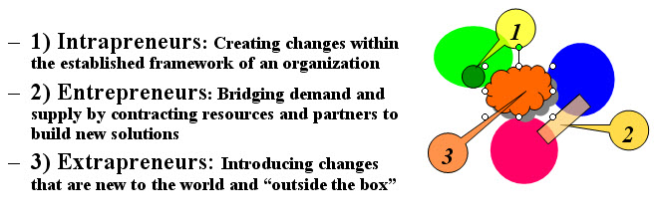
Figure 1: Three types of change agents.

Intrapreneurs who try to develop a new routine, a new solution, a new product or a new idea for exploitation within an organization. Because most organizations have rather rigid frames to work within, the Intrapreneurs are often stuck and do not easily generate a solution that on the one hand is new to the organization and on the other hand is close to the general frame that defines the organization (in terms of mission, governance, management, business process, machinery, clients, suppliers etc.).

Entrepreneurs who basically build up a new Win-Win-relation between at least two organizations or partners: a problem owner (a customer, a client, hungry people) and a set of resource owners (suppliers, professionals, food providers), so that the problem is solved (Value to the Customer) and resources are capitalized (Value to the Producer)

Extrapreneurs who works in a rather unstructured environment in-between different organizations and contextual frames for human action, such as Academia, Industry and Public Authorities. They figure out substantial innovations that shake the current ground and offer a new unique common ground that is new not only to people and organizations involved but also to the whole world.

We think that the most important change agent in the present historical situation is the Extrapreneur. In a textbook on Innovation Management another typology of changes and innovations is discussed of relevance in this context:
“Essentially we are talking about change, and this can take several forms; …
- Product innovation – changes in the things (products/services) that an organization offers.
- Process innovation – changes in the ways in which they are created and delivered.
- Position innovation – changes in the context in which the products/services are introduced.
- Paradigm innovation – changes in the underlying mental models which frame what the organization does. “ (Tidd & Bessant, 2009, pp 21)
In this typology, obviously it is the change of paradigm, of taken-for-granted frames-of-references, of mentalities and of business models where the societal entrepreneur is most fit for purpose. It is about mind-shifts and due to general inertia and the costs of change. The customer, client or the target organization must be motivated to enter such a mind-shifting learning process. We think the best way to do that is to involve them from the start in the process, which we will return to later (section 5).

3. The civilization making process
Giambattista Vico (1668-1744) was one of the first philosophers that elaborated more deeply on the relations between “reality” and “poetry” (originally meaning what we can express and create with language). For Vico, both language and societal reality are collectively constructed commons made by people over a long period of history. Many features in these societal work processes are made “spontaneous”, without a blueprint, and with a complex net of components that hang together as a culture.

Vico’s model (Vico, 1979) of the civilization process is composed of four tropes that build up the set of shared commons and societal instruments in a logical and chronological sequence (“corso”) where each layer becomes the background for the next layer until the Ironic trope triggers the next civilization process (“ricorso”). According to our view, this is the actual situation for Western Culture that necessitates a new generation of societal entrepreneurs and societal architects. The four tropes or phases are depicted below (see figure 1):

1) The metaphoric trope:
Being in the World, Common Sense, Theocracy,
Natural habitats, Natural rhythms, Natural matters
2) The metonymic trope:
Living in Estates, Common Property, Aristocracy,
Cities, Local clocks, Artificial matters

3) The synecdoche trope:
Working in Organizations, Common Systems, Democracy,
Nation states, Standard time, Societal matters
4) The ironic trope (Wallin interpretation):
Learning in Living Labs, Common Futures, Ideocracy,
Glocal transit halls, Time Zones, Digital matters

Degree of artificiality
Historic era (logarithmic scale)
Figure 2: Vico’s model of the civilization process. (This author’s interpretation of Vico).

2.1) The metaphoric trope:
This is the start of a new civilization in which people share their sensual experience of the world as it appears for the normal senses when people see, hear, smell, taste and feel different features of the world such as sunshine, thunder, fire, blood, and sexual intercourse. These shared experiences constitute the first common ground and the first common sense of the world. To communicate about it a primitive language evolves by trials, errors and corrections to designate some of the outstanding features of these shared experiences with primitive symbols, signs, utterances, expressions and single words. The world is endowed with general qualities like Up-Down (based on the experience of gravitational forces), Cold-Hot (based on the experience of weather, cycles of days and seasons) and Soft-Hard (based on experiences of different matter, such as flesh and bones).

2.2) The metonymic trope:
As Lakoff and Johnson explain in their book on “Metaphors we live by”:
“Metonymic concepts allow us to conceptualize one thing by means of its relation to something else. When we think of a Picasso, we are not just thinking of a work of art alone, in and of itself. We think of it is terms of its relation to the artist, that is, his conception of art, his technique, his role in art history, etc….. Thus, like metaphors, metonymic concepts structure not just our language but our thoughts, attitudes, and actions. And, like metaphoric concepts, metonymic concepts are grounded in our experience. In fact, the grounding of metonymic concepts is in general more obvious than is the case with metaphoric concepts, since it usually involves direct physical or causal associations.” (Lakoff & Johnson, 1980, pp 39).

If the metaphoric trope made it possible to put the “first names” on creatures and phenomena in the world, the metonymic trope contributes with the “second names” and additional attributes of the subject matter, indicating relationships, associations, heredity and familiarity with some of the already named features of the world. The boy named Stone was perhaps related to a man named “Sunshine”, being his father, so it would be meaningful to call him “Stone Sunshine” as a grown up individual. This made the shared common world much richer linguistically and also interwoven so that each person, thing or place could be related to other persons, things, places, times and other “co-ordinates” of the world. The world was given a socio-linguistic and time-geographical frame-of-reference, a semantic web that made the world much more intelligible down-to-earth, rather than only up-to-heaven.

2.3) The synecdoche trope:
In this phase there is a general systematization going on, so that the semantic web developed so far and the contextual bindings of the phenomena are made more evident, simple and structured into more elaborated and scientific theoretical and fabricated frameworks, such as Linnaeus taxonomy for plants, the subdivision of the whole territorial world into autonomous nation states, a central registration of all landed property for taxation purpose (“rent on living space”), national bookkeeping of all individual citizens to keep track of their residency and taxation duties, a national calendar with a common set of holidays, national celebration days and defined rules for the measuring of personal wealth. The principle is that of pars-pro-toto, i.e. that one exemplar of a thing, a person, a place, a day or a creature can re-present the whole population of the same type of creatures as all individual examples are handled equal, follows the same rules and are socially defined according to the same template. Different procedures evolve to make the proper selection of the best representative, such as the selection of people that can act on behalf of all citizens.

2.4) The ironic trope:
In this last phase of the civilization process (which Vico have only indicated in its details), the theories worked out for the understanding and control of the Welfare System as a socially constructed artifact begin to crack and disintegrate. On the one hand it is too complicated for new inhabitants such as immigrants and aliens that – according to the theory of the Welfare System - are expected to be “equal” in the sense that they are “similar” and also should follow the rules set up for the citizens and adjust to the templates worked out. But that is very difficult for people with another mother tongue, another religion, another concept of the family institution etc. So a new social division takes place, not between the Masters and the Subjects as in the earlier era, but between the Aboriginals (“native citizens”) and the Aliens (“immigrants”) living in the same geographical territory.

On the other hand the Welfare System is too simple to allow a very high degree of freedom for entrepreneurship, innovation, new lifestyles, new arts, new housing and new family types. So an additional social division takes place, the one that differentiates between the Ordinary Citizen - the one that the system can recognize and handle as a Patient, an Employee, a Student, a Resident, a Retired, etc - and the Deviant Citizens - the special and unique persons that the system don’t have the templates for, such as a transvestite Muslim billionaire that converts his house in Sweden to a new international church with a for-profit business model to offer higher international education integrated with services for the poor.

When such “abnormal” behavior is enacted, the ordinary citizen begin to wonder: is this a phenomena you should expect to happen more often within “our” society, or is this phenomena produced by some artists or provocateurs that just would like to make us aware of what the Welfare System could be if all of its potential is actualized in its extreme: Shall I apply Theory or should I watch Theatre? That’s the key question in the ironic epoch.

In Vico’s term, it is time for Ricorso, a fresh new start with the Metaphoric trope: to find a new common sense and a new common ground for the further co-creation of the civilization. This is in our view the key challenge for the post-ironic epoch and obviously we need some new competencies for serious and professional societal entrepreneurship to do something about it!

4. Commons and the irony of the commons
Each generation of human beings is entering a world that they have not created by themselves and they have to accept most of reality as a totality with only small pockets of freedom for the own construction of a more personal and suitable world. Most of these features and institutions are taken-for-granted just as the air in the atmosphere is taken for granted as a “natural” feature of the world. You don’t have to bother about these things because they are already taken care of by the context or environment you are in – such as a family, a language, a nation, a community or a city. Instead the energy is devoted to those more daily and specific components of the present world that you must pay attention to or have to care for, such as food on the table in order to complete the daily meal before going back to work. In many of these situations we can identify a background, a socially shared and taken-for-granted frame-of-reference, on which or into which we can place a foreground, a piece of reality in focus for our concern such as the food and the bottle of wine put on the table.

Our current society is heavily biased towards the foreground. We notice the message but not the media or the context for the message. We build factories for the mass-production of consumer goods but do not care about the effects on the environment when all these goods are consumed, i.e. destructed and turned into garbage. We are more or less forced to engage in discussions where the categories, key concepts and worldviews in the frame-of-reference for the discussion is taken for granted by the partners involved. Only occasionally, when a longer time or deeper considerations are allowed, we can question and criticize the very framework for our thinking, talking and acting.

Commons can be seen as the backgrounds that give the deeper meaning to the foregrounds of daily life. They always come into existence before the foreground (first a common vision, then daily collaboration), are larger (first land, then real estates for buildings) and they define the potential rather than the actual (first the genotype, then its phenotype). They also constitute the language available for articulations of meanings and the degrees of freedom available for what can or should happen in the foreground. They operate like a constitution that delimits what is possible and indicates what is “right”. Commons define the frame within which you are able to behave correctly – without risk! To go outside the frame is to be – almost – criminal.

One important aspect of the commons is that their reproduction and regeneration mostly is simply a matter of usage, just as our daily language survive by our use of it. But if we don’t pay our attention to them and don’t care for their sustainability, they can easily deteriorate such as the Family as a social institution or the Market as a fair mechanism for exchange of goods and services. Another important aspect of the commons is that they seem to be impossible to construct or re-establish by our current social instruments and technologies just like love between people cannot be forced on them. A sustainable common must be the result of a joint voluntary mass collaboration for co-creation and continuous re-creation of means to share common interests, such as the re-production of the population via a Family institution and a democratic governance that exclude corruption and the distribution of human rights and duties via the Market.

One of the general problems identified in the scientific studies of commons is “Tragedy of the Commons” (Harding, 1968) based on the low degree of concern for the common good by ordinary people which leads to deteriorated commons of land, water, air and other physical resources due to heavy exploitation of the common for private purposes only. In the modern society, the Institution of Promise (that you can trust what people say) is at risk when exploited for private and criminal purposes, as when you rob an old lady by pretending to be her new home service assistant.

In the digital world of commons, the quite opposite features can be observed as examples of the “Comedy of the Commons” (Lessig, 2007) where co-creation and use of ideas lead to very creative commons of immaterial digital artifacts that are shared in a virtual community and steadily growing as a shared, common assets if Intellectual Property Rights are handled with care, such as marked with the Creative Common. In the knowledge economy the most important exchanges occur in conversations where people share ideas, knowledge, experiences and opinions – for free!

The Irony of the Commons is that we tend to discover them too late, so when we need them most, they have deteriorated or been converted into crack-ware that cannot work as fruitful common backgrounds anymore. And if we try to make a formal organization of the old taken-for-granted common it would probably show up as an ironic expression of what we were thinking of. Commons cannot be formally organized by the same principle reason that love cannot be organized. It has to be cared for, not counted on via a formal contract of rights and duties about the number of kisses you could expect per day per partner.

In the present attention economy, what code-of-ethics should be developed to reduce the most obvious destruction of people’s attention space by commercial advertisements? Have we switched to something else than a TV-program when more than 60% of the expected attention from the viewers is devoted to ads and repeating, dull, in-attractive commercials that disturb the mental capacity to attend the other 40% of time to an announced American drama? What was earlier a simple expression of a well-established theory of every-day life (common sense) turns out to be an articulation of an ironic theatre play (artificial show) with actors that exaggerate and detach the drama from its normal connections to the (detoriated) background so that the implicit and taken-for-granted but cracked background becomes visible: reality is dis-covered as a made-up world. In the post-ironic epoch it is not even possible to distinguish the ads from the program: the demarcation line is blurred or has disappeared, making the media the true message.

As Illustrated in the figure below, a common land or a domain can be exposed to different subdivisions due to heritage roles or similar, so that the domain is cracked down to a set of unusable units without any value at all.

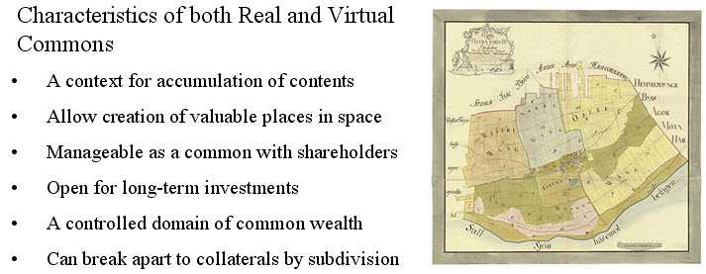

Figure 3. Characteristics of commons when exposed to enclosure, privatization and subdivisions illustrated by a map on earth reforms in Sweden to make agriculture possible.

The agricultural land reforms in many western countries in the 18th century can be seen as an example for what is going on in our knowledge domains, political domains, religious domains and economic domains where people have a general interest in the fundamental matters that once upon a time constituted the core matters of the common but where that interest is no longer possible to cultivate as no one of the subdivisions of the domain is suitable for their current interest in knowledge, politics, religion or economics.

So a major challenge for the present post-ironic age is to find a new common ground that we all can agree upon as a frame-of-reference for the further co-creation of the civilization including a new common sense of what it might mean to be a human being on Planet Earth the coming decades. In our view we have to transcend and go beyond many of the borderlines drawn up in our different domains of space, time, physical objects and other matters. Therefore we have begun to talk more about Trans-National concepts to free the ground from current national borderlines. We also talk about Trans-Disciplinary research and education to make possible disruptive thinking that goes outside the box. By this we can open up a rather fresh new look on the origin and evolution of a common, rather than considering the current structure of the domain as a taken-for-granted state-of-affairs.

5. Conversity of Busyland and its CoLabs
Modern virtualization techniques can support and enhance such Trans-National and Trans-Disciplinary collaboration. The Conversity® model is a trademarked concept for the generation of collaborative learning and enterprising and has evolved over the last ten years into an operational model that now is under implementation with modern ICT software and instruments for collaboration and sharing of digital commons created in the learning processes.

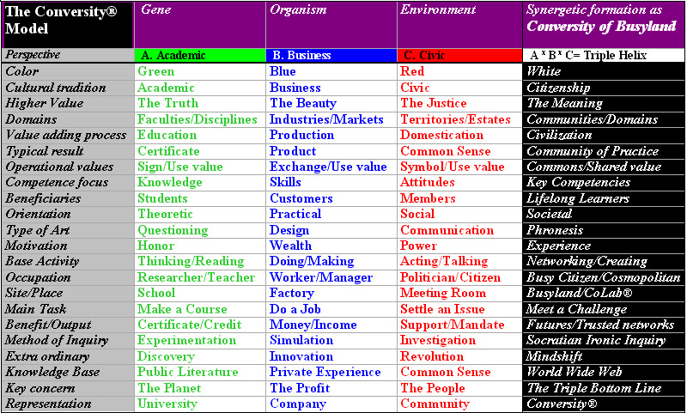

Figure 4 The Conversity model for synergetic blending of characteristics from the Academic, Business and Civic tradition for lifelong learning.

The figure above presents some of the key aspects of the model that is based on the principal idea that a modern learning environment must be composed of values, code-of-ethics, pedagogies, instruments and collaboration procedures that regretfully have evolved separately in the Academic, Business and Civic sector up to now. The Conversity model tries to generate synergetic blending of three social systems and traditions and the resulting synergy is indicated in the rightmost column in the figure.

The old Greek Academy was just the name of a place where philosophical conversations were going on. The same goes with Busyland, which is a virtual city-state up in the clouds, where the conversations and learning processes in societal entrepreneurship are going on. Our ICT platform is still in development but uses state-of-the-art technology for community-based and collaborative learning, working and living in digital habitats.

6) Work in progress and business modeling
Perhaps modern ICT most be considered as part of the general set of languages, communication and collaboration instruments for civilization making. Over the very last two decades the Internet has evolved into a global hypermedia for authoring, talking, viewing and collaboration in the form of social and professional networks. Some three generations of the Internet has been identified and discussed over the last ten years.

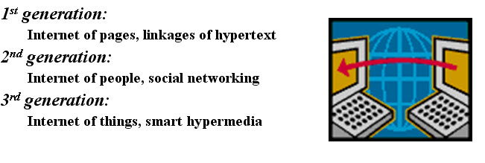
Figure 5. Three generations of Internet for support and enabling of business models

With Internet as a supporting or enabling structure for learning, enterprising, social networking etc, it is natural to consider the art of business modeling in relation to these three generations of the Internet.

Enterprise-I for value exchange follows the traditional industrial growth model with the market as the medium for value exchange between a buyer (consumer) and a seller (producer). Those who are engaged in the production are considered as workers and must be paid for due to their allocation of personal attention to their work. The classical Class-Model for distance education is close to this model.

A rather new business model, we can call it Enterprise Model-II, is currently discussed in the literature (see van Ommeren, 2009) as the logical consequence the 2nd generation of Internet with the option of letting the customers become partners in the production process by participatory design of new products, services and events. It is a more elaborated collaboration oriented model for mobilization of professionals and amateurs into a common co-creative permanent or ad-hoc Living Lab (see Mirijamdotter et.al, 2007). Living Labs can be seen as one of the most recent generations of innovation spaces where academia, industry, governments and ordinary citizens collaborate in different clusters and business eco-systems. For complex systems of services it is necessary to have the complex of services integrated and easily adaptable to its context, such as energy production in a housing area or mobile navigation services in a mountain area. The Living Labs model starts with the end-users need in their daily life context and that population should join the other stakeholders from the very “first mile” of the innovation process.

We are currently working with a business model that goes beyond the Living Lab concept to extend the collaboration further and in the direction of a Community-of-Practice with a Digital Habitat of its own (Wenger & White & Smith, 2010). In this context, we can call it an Enterprise Model-III. This model is not yet visible on the market but can be expected to show up when a critical mass of users is networking and collaborating “up in the clouds”. It is based on Web 3.0 – a web of things- and micro-meanings that can be picked up from “smart instruments” out there. Many products and systems of today are equipped with different kinds of sensors, processors, transmitters and other “micro”-components of ICT. They are sending messages to other smart artifacts and to people that have their attention set for receiving messages on the actual channel. Web 3.0 is also called the semantic web because most signals and messages will have no meaning if there are no meta-data structure imposed that give meaning to a specific signal – such as a wake-up call. One of the many new opportunities for Enterprise-III models is to make crowd funding for its investments by asking potential users and stakeholders if they want to join the effort to build a new future, a new book, a new movie or another piece of art.

Our own more detailed design and construction of such a Community-of-Practice is called a CoLab®, also trademarked, and we are currently implementing four such CoLabs, related to some EU-projects within the Lifelong Learning program:
- CoLab G8WAY for transitions between education and work in general and between different interships and temporary placements in digital habitats in particular.
- CoLab R3LPlus for the establishment and management of sustainable learning regions in general and LEADER areas in particular.
- CoLab CBVI for establishing a nod in a European network of Cross Border Virtual Incubators.
- CoLab USBM for the design and implementation of suitable business models for lifelong learning offerings on the global market

The Enterprise Model-III for a CoLab is oriented to personal and cultural exchange of means and meanings where conversations are crucial for this exchange of ideas, knowledge and experiences. It is a Inducer – Assumer oriented model for the co-creation of both big and small meanings, such as the meaning of a piece of art and the meaning of life on planet Earth, where the output is a shared, common meaning worth learning more about and caring for.

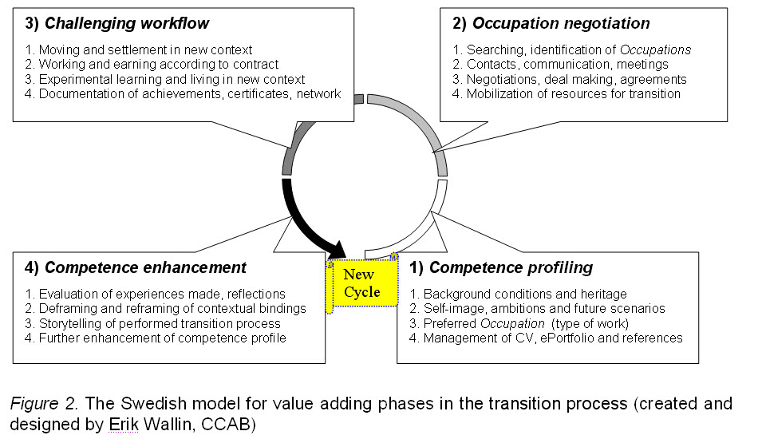
Figure 6. Enterprise-III modeling for a specific societal enterprise (G8WAY for education-to-work transitions).

Above is a working model for the value adding process in the Swedish implementation of the G8WAY transition from education to work, in which the idea is that participants and users of the model will contribute not only to the own, personal career, but also generate experiences, information and insights from a placement that others in the community can take advantage of in their lifelong career planning.

In difference to the other enterprise models, the Enterprise-III model is almost totally devoted to future matters: the World in the Future to be realized. One of the models used for converting original ideas from challenges to new societal solutions is called Crowd Sourcing, meaning that the Enterprise can get financing in advance (by offering “futures” to be part of the “vision”) rather than afterwards (by addressing “invoices” for produced “facts”). Lifelong learning could be seen as one of the most promising industries in the new experience based economy. As such it has stronger relations to other branches in the creative industry - such as interactive media, tourism, theatre, film, game, adventures, sports and dining - rather than to only other parts of the education system (the situation today). Learning history by playing a role in a historical drama is a case in point. The value is based on experiences from a unique event that typically is difficult to scale up to a wider audience or to repeat too often at the same place.

Our current work in the field of lifelong learning is targeted to create a new Enterprise-III model for experimental learning and testing of societal innovations that might be good not only for Profit, but also for the People and the Planet (Elkington, 1997) using the business modeling instruments developed by Alexander Osterwalder and others (Osterwalder & Pigneur, 2010) as these allows for rather easy integration of People and Planet in the costs and revenues of a business model.

7. Discussion
Vico’s dictum for learning “verum ipsum factum” means that if you would like to know the truth about something, you have to create it. Applying that to the civilization process means that in order for ordinary citizens to know the truth about their own civilization, they have to create it. The Conversity of Busyland with its CoLabs is a serious effort to relate lifelong learning to this challenge and making people not passive recipients of a culture that “others” have created, but more of active co-creators of their own destiny as cosmopolitan People on Planet Earth within the constraints and resources that are or can be made available for that purpose. A first version of the business model is currently under implementation in the clouds as a virtual academy for societal entrepreneurship based on the ideas and frameworks elaborated on in this paper.

References
Berger, Peter L & Luckman, Thomas (1967). The social construction of reality, Doubleday Anchor, New York.

Elkington, J (1997): Cannibals With Forks: The Triple Bottom line of 21st Century Business. Capston, Oxford, 1997

Harding, G (1968): “The tragedy of the commons”, Science, Vol. 162, No 3859, pp 1243-1248.

Lakoff, G. & Johnson, M (1980): Metaphors We Live By, The University of Chicago Press, Chicago

Lessig, L (2007): The Vision for the Creative Commons: What are We and Where are We Headed? Free Culture, in Open Content Licensing: Cultivating the Creative Commons, Brian Fitzgerald, ed., Sydney: Sydney University Press, 2007.

Mirijamdotter, A., Ståhlbröst, A., Sällström, A., Niitamo, V.-P., and Kulkki, S. (2007): “The European Network of Living Labs for CWE - user-centric co-creation and innovation”. In Basden, A., Mirijamdotter, M., and Strijbos, S. Integrating Visions of Technology: Proceedings of the 9th Annual CPTS Working Conference, pp. 79-90, April 25 - 28, 2006, Maarssden, The Netherlands.

Van Ommeren, E et.al. (2009): Collaboration in the Cloud, Microsoft & Sogeti, the Netherlands.

Osterwalder, A & Pigneur, Y (2010): Business Model Generation – A handbook for Visionaries, Game Changers, and Challengers. John Wiley & Sons, Hoboken, New Jersey, USA.

Tidd, J & Bessant, J (2009): Managing Innovation – Integrating Technological, Market and Organizational Change, 4th edition, John Wiley & Sons, Chichester.

Wenger, E & White, N & Smith, JD: (2009): Digital Habitats: Stewarding technologies for communities. Portland, USA: CPsquare.

Vico, G. (1979). The new science of Giambattista Vico. Ithaca: Cornell University Press

