##### Volunteer Application Form

##### TO BE COMPLETED BY THE VOLUNTEER CANDIDATE

*If you are interested in our project, please fill in our application form and send us back to* [**info_romayouthcentre@yahoo.com**](mailto:info_romayouthcentre@yahoo.com) **and roved** *. Remember that we don’t know you so it is necessary that you give us as much information as possible (this questionnaire will really helpful in our selection.). Please, be honest and try to concentrate in the information that could be related to our project (do not write your whole CV again)*

|  |
| --- |
| ***First Name: Home Address***  ***Street:***  ***Last Name: City/Town:***  ***Postal Code:***  ***Date of Birth: Country:***  ***Sex:***  ***Nationality: Home Phone:***  ***Mobile Phone:***  ***Passport No. or Identification Card No: E-mail address:***  ***Any Important Medical Issues? Diet concerns?*** |

***About yourself***

|  |  |  |  |  |  |  |  |  |  |  |  |  |  |  |  |  |  |
| --- | --- | --- | --- | --- | --- | --- | --- | --- | --- | --- | --- | --- | --- | --- | --- | --- | --- |
| ***What is your first language?***   |  | | --- | |  |   ***Other languages you speak Language: Speaking: Reading: Writing:***  ***Fluent = 1***   |  |  |  |  | | --- | --- | --- | --- | |  |  |  |  | |  |  |  |  | |  |  |  |  | |  |  |  |  |   ***Good = 2***  ***Basic = 3***  ***Beginning = 4*** |

|  |
| --- |
| ***Tell us about yourself. What are your interests & hobbies? Skills and talents?*** |

***Education and Training***

|  |
| --- |
| ***Please summarize your educational background. (i.e. primary school, secondary school, university, college, vocational training, etc.)*** |

|  |
| --- |
| ***What practical work experience do you have? (i.e. employment, part-time jobs, casual jobs, etc)*** |

|  |
| --- |
| ***Do you have any experience in voluntary work?***  ***What type of voluntary work (social work, youth work, organisational work, church work, etc.)?*** |

|  |
| --- |
| ***Do you have any experience in multicultural work (Working with Roma communities, minorities, disadvantaged young people?*** |

|  |
| --- |
| ***Have you applied for voluntary service with other organisations?*** |

***Motivation***

|  |
| --- |
| ***What are your motivations for taking part in a volunteer project?*** |

|  |
| --- |
| ***What are your expectations? What do you hope to gain from it in terms of knowledge, skills, experience?*** |

|  |
| --- |
| ***How do you think you can contribute to the project and to your new hosting environment?*** |

|  |
| --- |
| ***What do you think you’ll find difficult about doing voluntary service?*** |

##### Thank you for your application form

***Roma Youth Centre’s coordination office will review your application and contact you soon. If you have any questions or concerns please contact us:***

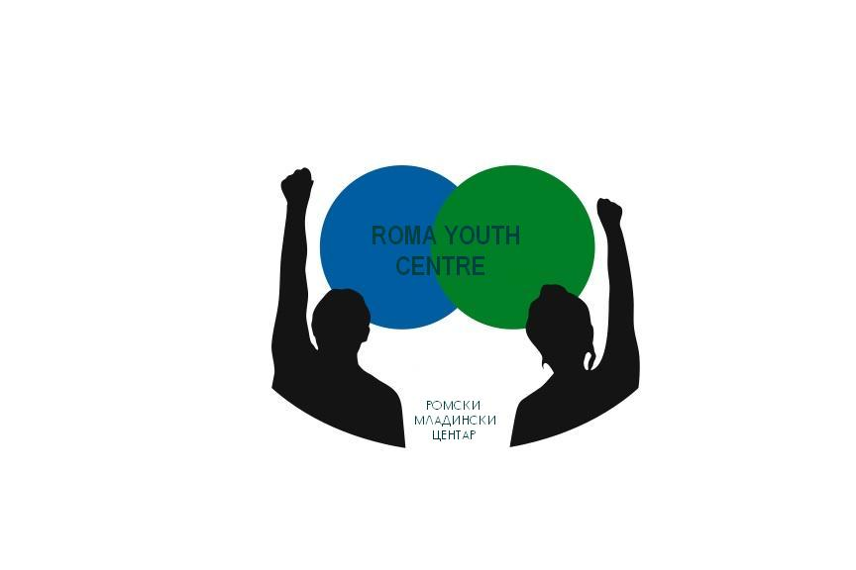

***Roma Youth Centre***

***E-mail:*** [***info_romayouthcentre@yahoo.com***](mailto:info_romayouthcentre@yahoo.com)

***Phone: +3931613691***

***Toso Angelovski Zidar 2***

***1300 Kumanovo, Macedonia***