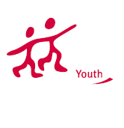

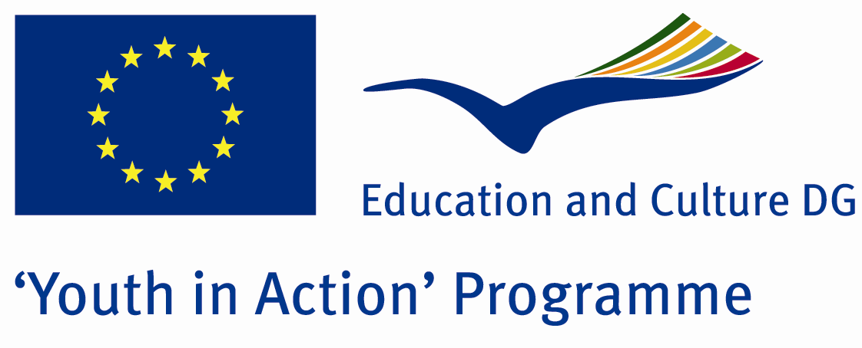

„Go volunteer, Go EVS!”

Erasmus+ K1 mobility

Training Course

Project proposal

Introduction

EVS is a “big adventure” for all the people and organizations enroll of this unique opportunity to know other culture, other language, habits, countries, etc..., independently of the motivations of all actors, we can’t NEVER forget the aims we must follow to achieve all the objectives we all attach with us in the projects we were/are/will be involved and the one’s written on Youth in Action Guide.
Develop specific and general training courses about EVS aren’t never enough, because the same project with different persons involved, can change completely and the main aim of this TC are to remind the Organizational tasks to keep the quality of the projects and partnerships, to provide the best opportunity for the volunteers, Organizations and Local Communities.
We know that this experience is too much important for all actors involved, and mostly for the Volunteer(s) who is physically, emotionally, educationally inside the project, and in the centre of it.
“Go Volunteer, Go EVS!” is a strong beginning to develop structured quality projects Erasmus+ programme, providing for Sending, Hosting and Coordinating Organization the importance to keep in mind the preparation of the volunteers, the structured service programme, the mentor(s) you can provide, the clear communication between all Actors, the conditions for all to take as much as you can from this experience.
As well as understand that ONE Volunteer are ONE Intercultural opportunity for you and your local community, ONE improvement for your organization, ONE chance to benefit of all motivation she/he can bring with him/her, ONE point of view of other landscapes and places in EU and not only.
Basically, ONE person open to share, to change, to learn, to live, to contribute, to grow, to improve, to be BETTER and more strong, and in other hand, representing one organization involved you must know clearly what’s the aims of Youth in Action in general, and know deeply the objectives connected with the EVS projects, what’s the tasks you have before, during and after the activity, and be totally aware of your responsibilities as an Non-formal Education provider.
The training course “Go volunteer, Go EVS!” is successful designed to give the base skills about European Voluntary Service for Sending, Hosting and Coordinating Organizations, and then go further with specify information about how to do the Planification, Implementation, Evaluation and the Follow-Up of the projects, using always the non-formal methods to promote the group reflections, sharing previews experiences, and group constructions.

Aim of the Training Course:

The main aim is to promote the European Voluntary Service within young people with less opportunity and to improve the quality of the projects with this target group in particular.

In concrete, the objectives are:
- To assist participants in clarifying the philosophy of EVS Short Term;
- To make the participants familiar with the EVS Short Term process (hosting & sending);
- To prepare the participants to developed quality EVS ST projects;
- To encourage the use and implementation of EVS ST in their countries and cities;
- To improve communication and co-operation between organizations;
- To discover possible motivations of volunteers, sending and hosting organizations within the EVS ST;

Methodology:
Based on Non-formal and informal learning methods, “learning by doing” is one of the most efficient ways of learning, the course concept have been created in a way that allowed for active participation and exchange of good practices between participants.
Non-formal and informal learning enables young people to acquire essential competences and contributes to their personal development, social inclusion and active citizenship, thereby improving their employment prospects. Learning activities within the youth field provide significant added value for young people as well as for the economy and society at large.

Participants should fulfill the following criterias:
- To be representative of the youth organisation or organisation working with young people, and to be able and authorize on behalf of its organisation to create future projects ideas;
- Must have basic knowledge about past Youth in Action Programme on decentralised level;
- Preferable having experience from minimum 1 multilateral youth exchange (other non-formal education experience will be additional advantage);
- Should be prepared to participate in follow-up or evaluation activities organised by us;
- Should be prepared to actively attend and contribute during the full duration of the TC;
- Be motivated to develop their knowledge and competence the specific field and to share their experiences with other participants;
- Commit themselves to their function for future activities in the field of youth policy and be prepared to pass on the others the knowledge and skills gained during this training course;
- Be fluent in English;
- Beign 18-25 years old.
Financial conditions:
The TC is scheduled for September 19th-24th 2014 and will be hosted in Drobeta Turnu Severin, Romania. Financial support is under the European Commission’s “Erasmus+”-programme granting scheme. If approved, all costs will be covered except for 30% of the international travel expenses. The working language of the project is English.
Time plan and venue:
March 17st 2014, submission of the application form under Youth in Action Programme
Date of training course: September 19th-24th 2014
Venue: Drobeta Turnu Severin, Romania
Group size and duration:
Group:18 young people- 3 representatives from each partner organisation,
Duration of the activity will be 6 full working days (including arrival and departure)
As we need to apply in March 17st deadline, please be as fast as possible in being our partner and send us attached Partnership agreement.
We are looking forward to your positive answers... ☺

Aplicant Organisation:
Asociatia „Mod of Life”
E-mail: office@modoflife.ro

