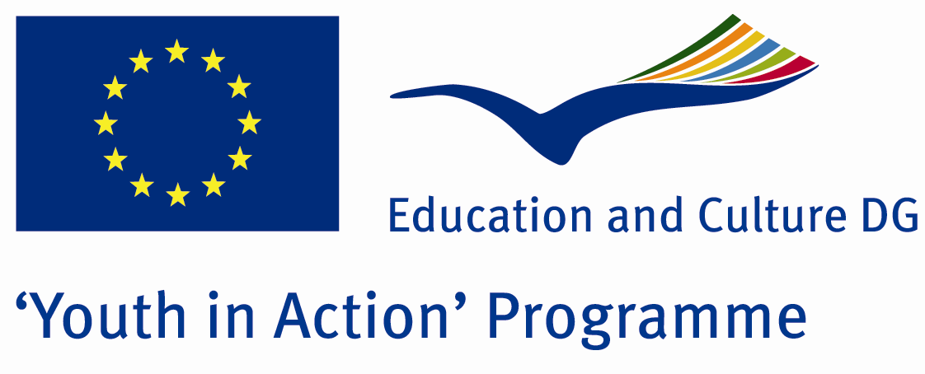

„Recycle IT!”

'Youth in Action' Programme
Action 1.1 - Youth Exchanges

Project proposal

Short description

Today when we live in 21st century we need to raise awareness about clean environment. The problem of clean environment and none well informed citizens is very large and we need to promote and raise awareness about importance of clean surrounding for our future. The point is that we need to include all people to work on this issue and through joint work promote inclusion of young people different backgrounds. We are all citizens of the world and we all need to take care of clean environment. Through working of environmental issue youngsters will have opportunity to work together, break barriers between people from different backgrounds, promote inclusion and tolerance, tried to be active in their local communities after exchange promoting joint work and raise awareness of joint problem.
This exchange is focused on personal and everyday contribution to sustainable development and environmental protection. Although of crucial importance for the future of mankind, sustainable development and environment protection are not the issues that people are really devoted to as much as they should be. In Romania, this issue is, unfortunately, very low at the list of priorities and young people are still not aware what global climate changes can bring and are bringing to their lives. Not many are ready to devote themselves to raising awareness of their co-peers on sustainable development as well to promote personal responsibility of each and one of us regarding protection of Earth and nature. We want to include all young people to work on this issue and to raise awareness among them that only if we are work together we can contribute to our local community. In that case, we want to organize exchange, which the topic will be ecology and rising awareness of environmental issues in our daily life and promoting joint work on the issue important for all of us.
"Recycle IT!" is also a project about art and culture with putting aspect on alternative art techniques - using materials that can be recycled and making something out of nothing. This exchange will raise the awareness of the protection of the environment, pollution that mankind is making, selection of garbage and garbage removal. When everyone works together, we can make the best use of our planet`s natural resources. When you recycle the products you use every day, like cardboard boxes, milk jugs, and soda cans, you give new life to items that used to be thrown away, you save energy and help lower greenhouse gas emissions in the process. This Youth exchange will be exactly this – youngsters working together to save environment. It will happen in Drobeta Turnu Severin, Romania with youngsters taking part in it - they will join creative thinking, exchange ideas, knowledge, and experience, positive examples through non-formal workshops, team building, role play, and creative workshops. The project will fight people ignorance towards the pollution they are making with garbage. Youngsters will make "a cleaning day" and using materials that should be recycled like plastic bottles, plastic bags, leaves, branches of trees will make a creative exhibition of sculptures, using art and creativity. The exhibition will be open for public on the last day when participants will present the idea of selective garbage removal and recycling in order to save the environment. During this exhibition youngsters will hear about YIA opportunities and be motivated to take active part in their communities. As a final result a promotional film and booklet will be created, and with information on environment pollution and ways to prevent it. Participants countries cultures will be present, European diversity will be promoted and tolerance and respect between youngsters coming from different backgrounds will be achieved.
Regarding to priorities of YIA programme we want to connect this project with active participating and social inclusion. We want to include people different background in order to show how big problem of environmental is and how we need to include all people from our surrounding. We want to collect people from different backgrounds (social, economical, ethnic) and show that problem of keep environment clean is joint problems never mind from which part we are.

Aim of the project:

The main aim of the project is to provide young people all around Europe an opportunity to get to know more about different ecological issues as well as to create new pieces of art by using creative recycling technique.

In concrete, the project objectives are:

- To raise awareness about today’s’ problem of environmental and importance of recycling
- To provide a ground for young people to meet and to learn new and creative ways for recycling the waste that is created by our everyday actions;
- To discuss about various environmental problems, especially those created by an extensive use of resources;
- To learn about various recycling techniques;
- Use art like tool for creative work and promote recycling;
- To create a manual for youth workers and educators on creative workshops using everyday garbage as a resource;

Methodology:

In the project we use non-formal education methods: workshops, brainstorming and discussions, ice-breaking games, simulations and role plays, presentations, challenges and a lot more. In addition we will use few more traditional methods like visits and round tables. The whole activity is perceived as a mutual exchange of learning situation based on participants’ experiences and opinions. Active participation, group and team work & learning by doing will form the methodological foundation of the exchange. Our aim is that participants can gain knowledge, skills and experience through learning by doing. As well we will do workshop about Youth in Action programme, YouthPass and we will try to set up some ideas for future projects.

Time plan and venue:
May 1th 2013, submission of the application form
Dates of project implementation: August 1th 2013-January 30th 2014
Dates of the Activity: October 18th (arrival day) –October 26th (departures day)
Venue: Drobeta Turnu Severin, Romania
Partner organizations
Right now we are looking for youth organizations based in Programme Countries that share an interest about this issue and are strongly motivated to cooperate with us in the framework of this project. Eligible countries are:
Programme countries:
Austria, Belgium, Bulgaria, Cyprus, Czech Republic, Denmark, Estonia, Finland, France, Greece, Hungary, Ireland, Italy, Latvia, Lithuania, Luxembourg, Malta, Netherlands, Poland, Portugal, Slovak Republic, Slovenia, Spain, Sweden, United Kingdom, Iceland, Liechtenstein, Norway, Turkey

As we need to apply in May 1st deadline, please be as fast as possible in being our partner and send us attached “Identification of the promoter” form. Deadline for documents submission by e-mail: April 28th 2013.
We are looking forward to your positive answers... ☺

Aplicant Organisation:
Asociatia „Mod of Life”
Web: www.modoflife.ro
E-mail: office@modoflife.ro

