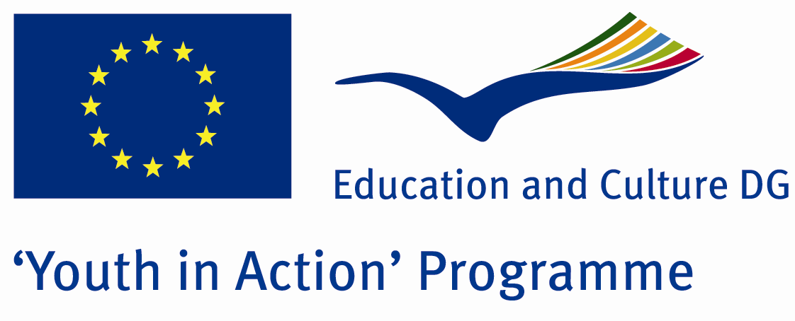

„Radio YOUth”

'Youth in Action' Programme
Action 1 - Youth for Europe
Sub-Action 1.2 - Youth Initiatives

Project proposal

Summary

The project “Radio YOUth” foresees the creation of a RADIO programme on the web that will be entirely managed by youth people from the partner countries. This process, which consists mainly in organisation, participation and communication, will enable youth to develop themselves and grow acquiring diverse competences useful at professional and personal level. We expect as well a great impact in the local community, mainly in youth people. The educational approach adopted will be non-formal education and the main learning methodologies will be learning by doing, cooperative learning, participation and peer to peer.
All youth have between 18 and 30 years old. This “youth initiative” main themes are the non-formal education and the active citizenship and participation. The activity will last for 12 months (August 1-th 2013 – July 31t-th 2014). The 2 first months will be dedicated to the preparation; the rest of the months will be dedicated to the implementation of the activities forecast, to the continuous visibility, to the valorization (last months) as well as to a continuous evaluation; during the last month it will be a final evaluation.

Aim of the project:

The main aim of the project is the development of an online youth radio entirely managed by young people

In concrete, the project objectives are:

- To create a space where young people can freely and creatively express their ideas and opinions on important European issues.
- To offer to young people an alternative to crime and social decay.
- To provide young people opportunities for personal and professional, acquiring skills and professionalism that can be spent in future in a business context.
- To create a space for development and trade that can approach youngsters physically distant.
- To promote active citizenship and participation.

Methodology and planned activities:

The project is planned using a wide range of methodological approaches. Mainly it is based on the toolbox of non-formal education/learning and the activities are learner-centered giving space for participants to mobilize the potential that is available in the group and work on the issues.

PHASE I - PREPARATION

The project will start with an Advanced Planning Visit that is aimed for the partners to fine tunne all the details regarding the project implementation. This meeting will be organized in September 2013 in Romania and will be attended by 2 participants from each partner organization. Details about the working programme of the APV is attached.

2) Contact with youngsters:
- Contact with other young people in different partner countries in order to enlarge the number of participants;
- Selection of young people interested in conducting radio programs;
RADIO programme will be managed entirely by young people (with the support of partner organizations) and it’s intended to be for youngsters. In this phase, we plan to look for the young people interested in the project, the research will done through partners net, private and public institutions, secondary schools and University. The youngsters have to show big motivation and will to be part of the project and they have to be in a condition of fewer opportunities. At the same time, each partner will undertake the research of young people to be involved in the project in his own country following the same criteria. In the end, we will have groups of young people from different countries, each of them composed of 4 or more youngsters.
3) Training young people:
Training through the non-formal education methods at local level (made by each partner) on the first issues to be addressed in RADIO programme.
Before the beginning of project, it will be organized a two-day meeting with young people selected. Each partner will hold the meeting with young people in his country in order to transfer them some basic knowledge about the first issues to be dealt during the project. So that having a better idea about such topics, young people can better organize the activities to be done during the project.

PHASE II - IMPLEMENTATION
Realization of the website for the RADIO programme:
- Installation and check the proper functioning of the software.
- Transmission test.
This phase will happen by mutual agreement with the involvement of all partners. It will be realized a common platform for the transmission of Radio programme in order to allow a greater interaction among all young people involved. In this stage also all the tests to verify the proper functioning of the instruments will be done. The selected groups will begin to come into contact with each other to decide the activities to be put into practice.
The project requires:
• Dedicated website
• Web cam and microphone
• Software for broadcasting audio-video
• Software social communities such as Skype and IM
The first necessary step is the creation of the website. It will also include all the information about the project and the Youth in Action Programme. There will also be a section devoted to documents that will be created during the project and that can be freely downloaded. The purchase of the domain will also give the chance to create specific email addresses.
To create a platform RADIO we will need to download and install special software to use. It is enough to use a special program, a video player that can transmit live images of the webcam and the audio and allow to more than one broadcaster to take part in the transmission, as well as to move between different rooms or transmit simultaneously multiple users.
Starting RADIO sessions:
- Preparation of the sessions.
- Communication between the young participants.
- Starting the Internet radio by young people.
Through the use of the most popular social networks (Skype, IM and Facebook) youngsters will be in contact with the local, European and international community, interacting with young people from all cultures and social backgrounds. In addition, through the chat box on the site, viewers / listeners from all over the world can also interact with each other.

PHASE IV - FINAL EVALUATION
- Evaluation of the project on young leaders
- Evaluation of Radio programs and activities done by youngsters
- Evaluation in general of the achievement of the goals of the project
In this phase, the impact of the whole project will be evaluated. Through group meetings and questionnaires done during the project, we will be able to evaluate the satisfaction of young people involved in the initiative and to analyze any problems encountered during the activities.
A month after the closure of the activities, final sessions will be organized with participants in order to have a final evaluation with creative methods and individual assessment through a short questionnaire which will include elements different from those assessed during the year (eg. the differences they feel in themselves after participating in the activities, how they used the results of their participation, what has changed in their lives, if they talked with their family and friends about the project, if their expectations were fulfilled, etc.) .
To assess the impact within the territory, all the information provided by young people intervened in the Radio on the Internet through the most important social networks that exist on the Internet, as Messenger, Skype and Facebook will be gathered. Since broadcasts on the Internet, such data will be taken periodically to document the participation of young people not directly included in the initiative, but participants. We will separate the youngsters countries of partners and non-partners in order to assess more specifically the impact on the territory not only local but also regional, national and European level.

Time plan and venue:
May 1th 2013, submission of the application form
Dates of project implementation: August 1th 2013- July 31th 2014
Venue: all partner countries
Partner organizations
Right now we are looking for youth organizations based in Programme Countries that share an interest about this issue and are strongly motivated to cooperate with us in the framework of this project. Eligible countries are:
Programme countries:
Austria, Belgium, Bulgaria, Cyprus, Czech Republic, Denmark, Estonia, Finland, France, Greece, Hungary, Ireland, Italy, Latvia, Lithuania, Luxembourg, Malta, Netherlands, Poland, Portugal, Slovak Republic, Slovenia, Spain, Sweden, United Kingdom, Iceland, Liechtenstein, Norway, Turkey

As we need to apply in May 1st deadline, please be as fast as possible in being our partner and send us attached documents needed to join the partnership. Deadline for documents submission by e-mail: April 28th 2013.
We are looking forward to your positive answers... ☺
Aplicant Organisation:
Asociatia „Mod of Life”
Web: www.modoflife.ro (web site under reconstruction at the moment)
E-mail: office@modoflife.ro

