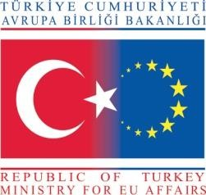 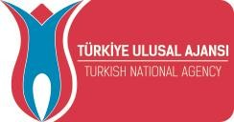 

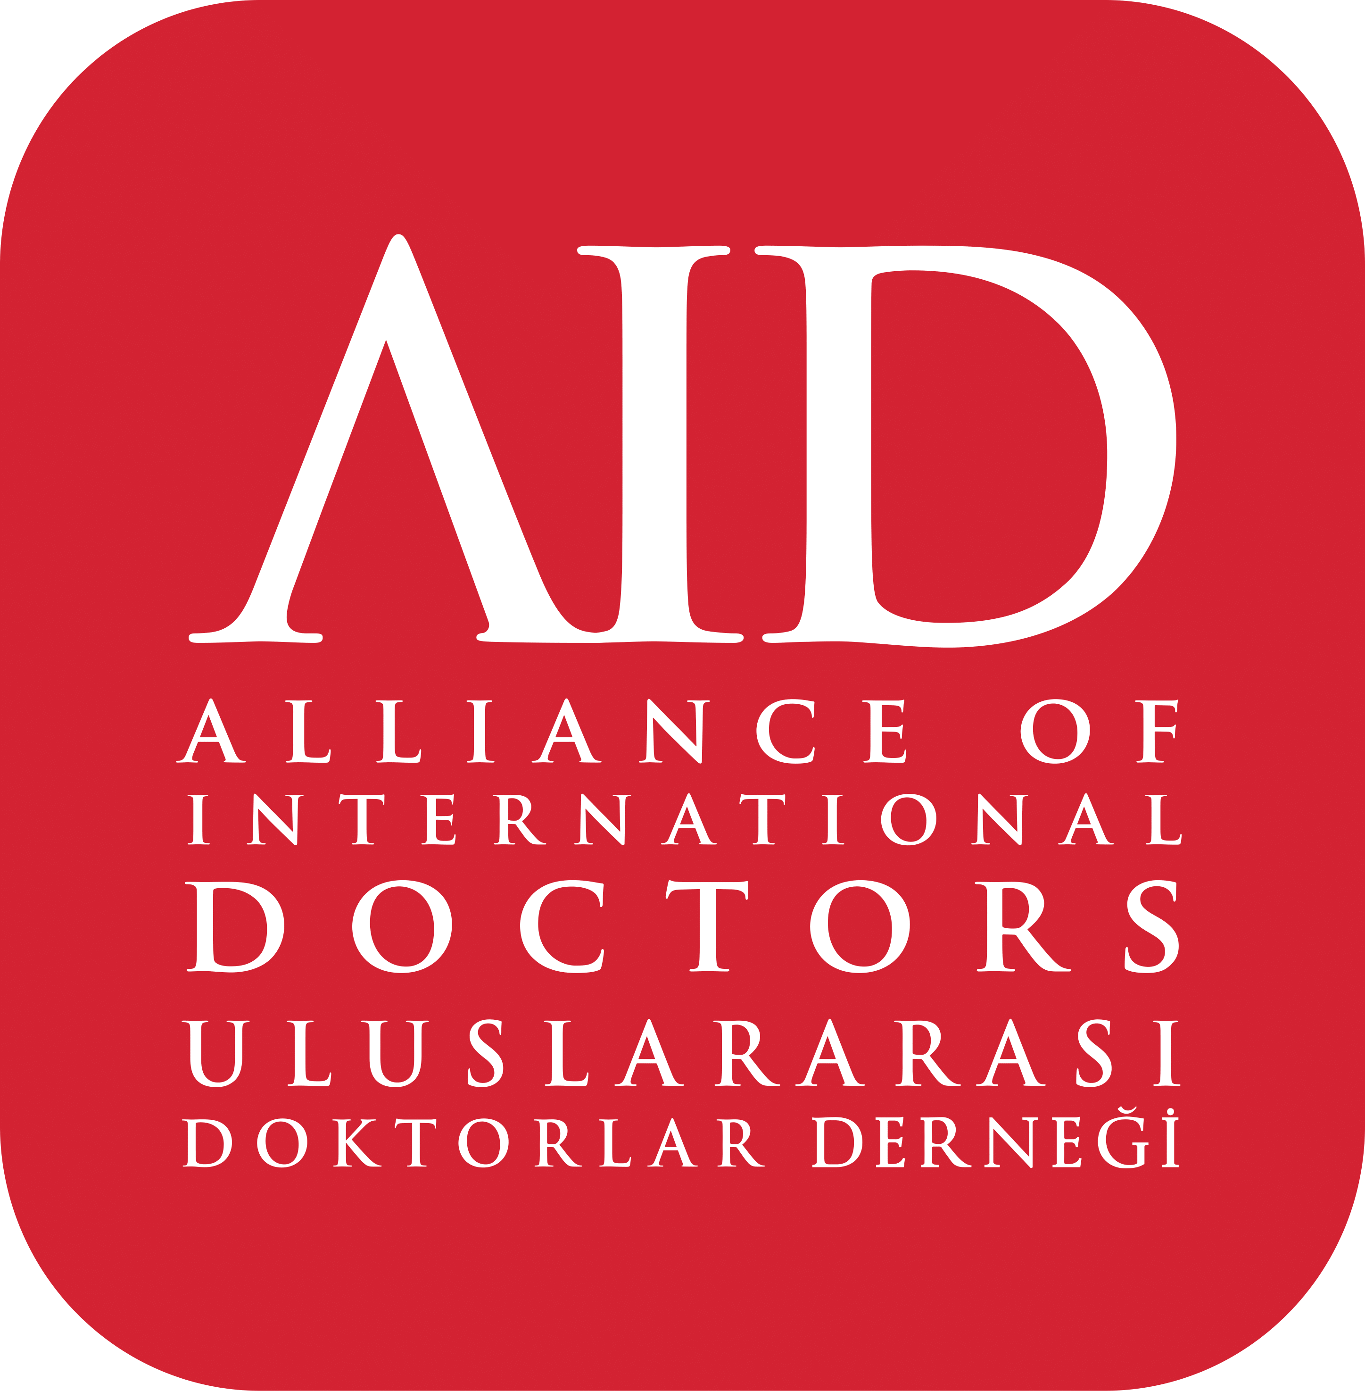

**Dear Partner,**

We are pleased to inform you that Uluslararası Doktorlar Derneği (Alliance of International Doctors) is preparing to submit a project proposal to the Turkish National Agency for the October 2024 deadline under Erasmus+ Key Action 210 – Small Scale Partnerships in Adult Education.

We would be honored to collaborate with your organization as a partner in this project.

**NAME OF THE PROJECT :** Empowering Integration: Enhancing Workplace and Educational Accessibility for Individuals with Acquired Disabilities

**APPLICANT ORGANIZATION:** Uluslararası Doktorlar Dernegi

**GRAND PROGRAMME :** Erasmus+

**SUB PROGRAMME :** Key Action 210 – Small Scale Partnerships in Adult Education

**PROJECT VENUE :** İstanbul, Turkey

**GENERAL AIM OF THE PROJECT:**

The primary aim of this project is to reduce the barriers faced by individuals with acquired disabilities in both professional and educational environments, while raising societal awareness regarding these challenges. The project also seeks to promote the social integration of individuals with disabilities by addressing the obstacles they encounter in their professional and academic lives.

**SPECIFIC OBJECTIVES ABOUT OUR PROJECT:**

1. To decrease the barriers in the workplace and educational settings for individuals with acquired disabilities, fostering their social inclusion.

2. To raise public awareness of the challenges faced by individuals with acquired disabilities, supporting their social integration.

Alliance of International Doctors (Uluslararası Doktorlar Derneği AID) would like to extend an invitation to organizations working in the field of inclusion, both locally and internationally, to join us as partners in this initiative. The call for partners is open to all Erasmus+ Program countries. The project will comply with accessibility standards and will be inclusive of individuals with disabilities.

There will be no participation fee.

* If your organization is interested in participating, we kindly request you to submit A completed Partner Identification Form (PIF) **before** Friday, 20 September 2024 to ebrusofi@aidoctors.org:

For any further inquiries or clarifications, please feel free to contact:

**EbruSOFİ**  
e-mail:ebrusofi@aidoctors.org  
mobile number: +90 539 373 2586

We look forward to your response and hope to collaborate on this meaningful project.