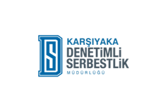
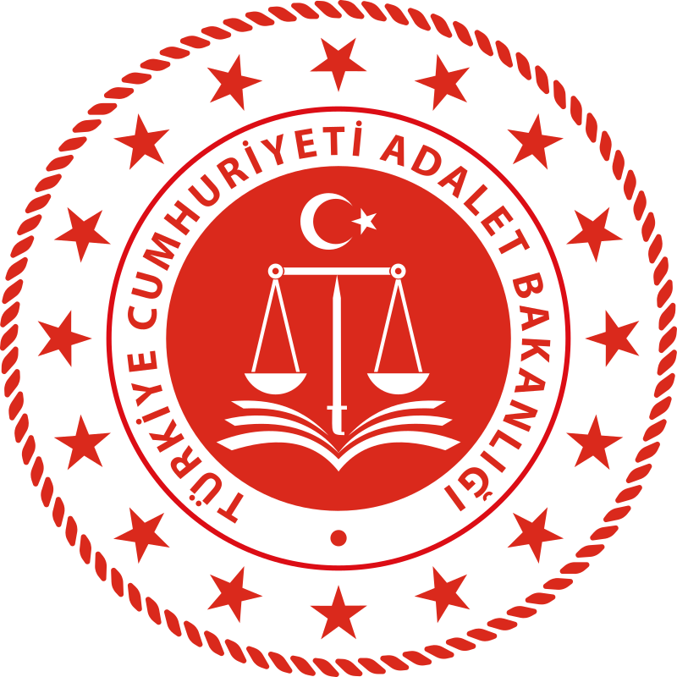
KARŞIYAKA DENETİMLİ SERBESTLİK MÜDÜRLÜĞÜ PARTNER IDENTIFY FORM

Identification of Partner Organisation
OID number | E10297698
Full legal name (English) | KARSİYAKA PROBATİON DİRECTORE
Acronym, if applicable | Karsiyaka DSM
National ID (If applicable)
Address | İnkılap Mah. Akdoğan Cad. No:4 Şirinyer Buca/İZMİR
Country | Türkiye
Region
P.O. Box
Post Code | 35100
City | İzmir
Web site
Email | dsm.karsiyaka@adalet.gov.tr
Telephone 1 | +90 0232 381 07 07
Telephone 2 (mobile) | +90 0542 2305643
Fax | +90 0232 381 38 28
Profile of the Organisation
Type of Organisation | National Public Body
Is your organisation a public body? | YES
Is your organisation a non-profit?
Main sector of activity
Title | Probation Manager
First name | KAYKAÇ
Family name | ORHAN
Department | Poject Manager
Position | Probation Manager
Email | dsm.karsiyaka@adalet.gov.tr
Telephone | +90 0232 381 07 07
Telephone 2 (mobile) | +90 0505 270 42 99
Same address as the organisation | YES
Fax | + 90 0232 381 38 28
Contact Person
Title | Youth Programs Coordinator
First name | DENK
Family name | ÇAĞDAŞ
Department | Erasmus Project Deparment
Position | Youth Program Coordinators
Email | cagdas.denk68@gmail.com
Telephone | +90 0542 230 56 43
Telephone 2 (mobile)

Background and Experience
Please briefly present the organisation / the group*
Probation; It means that a person serves his sentence under surveillance and supervision in the society, instead of being arrested or convicted and sent to prison for a crime he has committed.
Probation; It is an alternative punishment and execution system in which the suspect, defendant or convict is supervised and monitored within the society, and all kinds of services, programs and resources are provided for his recovery and reintegration into society. (Probation Regulation 2021)
Probation services were established by the "Probation and Assistance Centers and Protection Boards Law", which came into force on July 20, 2005.
Probation services are provided by the department in the central organization of the Ministry of Justice and by 144 Probation directorates in the provincial organization. There are 4 probation directorates in Izmir province, these are Izmir Probation Directorate, Karşıyaka Probation Directorate, Bergama Probation Directorate, Ödemiş Probation Directorate. Karşıyaka Probation Directorate is included in the Karşıyaka Judicial District; It serves 5 districts of Izmir, namely Karşıyaka, Çiğli, Menemen, Foça and Aliağa. Our directorate, with 55 personnel, is tracking 4789 files (obligors) whose records are open in the uyap system as of 22/12/2022. In our directorate, 10 Probation Specialists, consisting of Psychologists, Social Workers, Sociologists and Teachers, carry out educational improvement activities for people who have been sentenced and injunctions. Within the scope of these training and improvement studies; rehabilitation of those liable and Individual interviews, group studies and seminars are held to help them adapt to society.
Group Studies carried out by Karşıyaka Probation Directorate experts;
-Tobacco, Alcohol and Substance Abuse Intervention Program (SAMBA)
-Tobacco Alcohol and Substance Abuse Program for Young People (GNSAMBA)
-Anger Management Intervention Program
-FORKE-SIZ Program for Judicial Control Decisions
-Change for Life Program (HAYDE)
-It is a (SMOKING-FREE) Program for those who want to quit smoking.
In addition, within the scope of the training and improvement studies carried out, the obliged parties participate in seminar studies, vocational courses (Cooking, Beekeeping, Welding) and educational, socio-cultural, artistic and sports activities (painting course, mind games) in order to structure their free time, in cooperation with other Public Institutions and Non-Governmental Organizations. course, chess course, table tennis, cinema, museum visits, music recital) are guided.

What are the activities and experience of the partner organisation in youth work? Please provide information on your organisation’s / group’s regular youth work activities on local level.
Karşıyaka Probation Directorate has many years of experience in rehabilitation studies and social adaptation programs for young people. The institution operates in many areas such as reintegrating young people involved in crime into society, anger management, combating substance addiction and vocational training programs. Our directorate organizes capacity building programs, especially for youth workers to develop effective working methods with these young people. Activities in this field have made significant contributions to reducing crime rates and integrating young people into social life. Every year, an average of 150 young people benefit from the programs run by our directorate, and 60% of these young people can successfully integrate into social life after the program.

Please give information on the key staff/persons involved in this application and on the competences and previous experience that they will bring to the project.
Orhan Kaykaç (Project Manager): With 20 years of experience in probation and rehabilitation, Orhan Kaykaç specializes in working with young offenders. He holds a master's degree in social services and has led various national and international projects, successfully managing rehabilitation programs. Additionally, he has extensive experience in projects related to young offenders in Turkey and has developed best practices in this area.
Özlem Heptaşkin (Lead Social Worker): Özlem Heptaşkin has been working in social services for 15 years and specializes in the rehabilitation of young offenders. She has played a key role in developing and implementing anger management and substance abuse prevention programs at the directorate. Özlem is recognized for her innovative approaches and practices in working with youth.

Çağdaş Denk (Youth Programs Coordinator): Çağdaş Denk has 10 years of experience in youth work and vocational training programs. He has been involved in various projects aimed at the education and labor market integration of at-risk youth and has developed training programs for youth workers. He has also organized educational programs that raise awareness among youth about gender equality and social cohesion.

