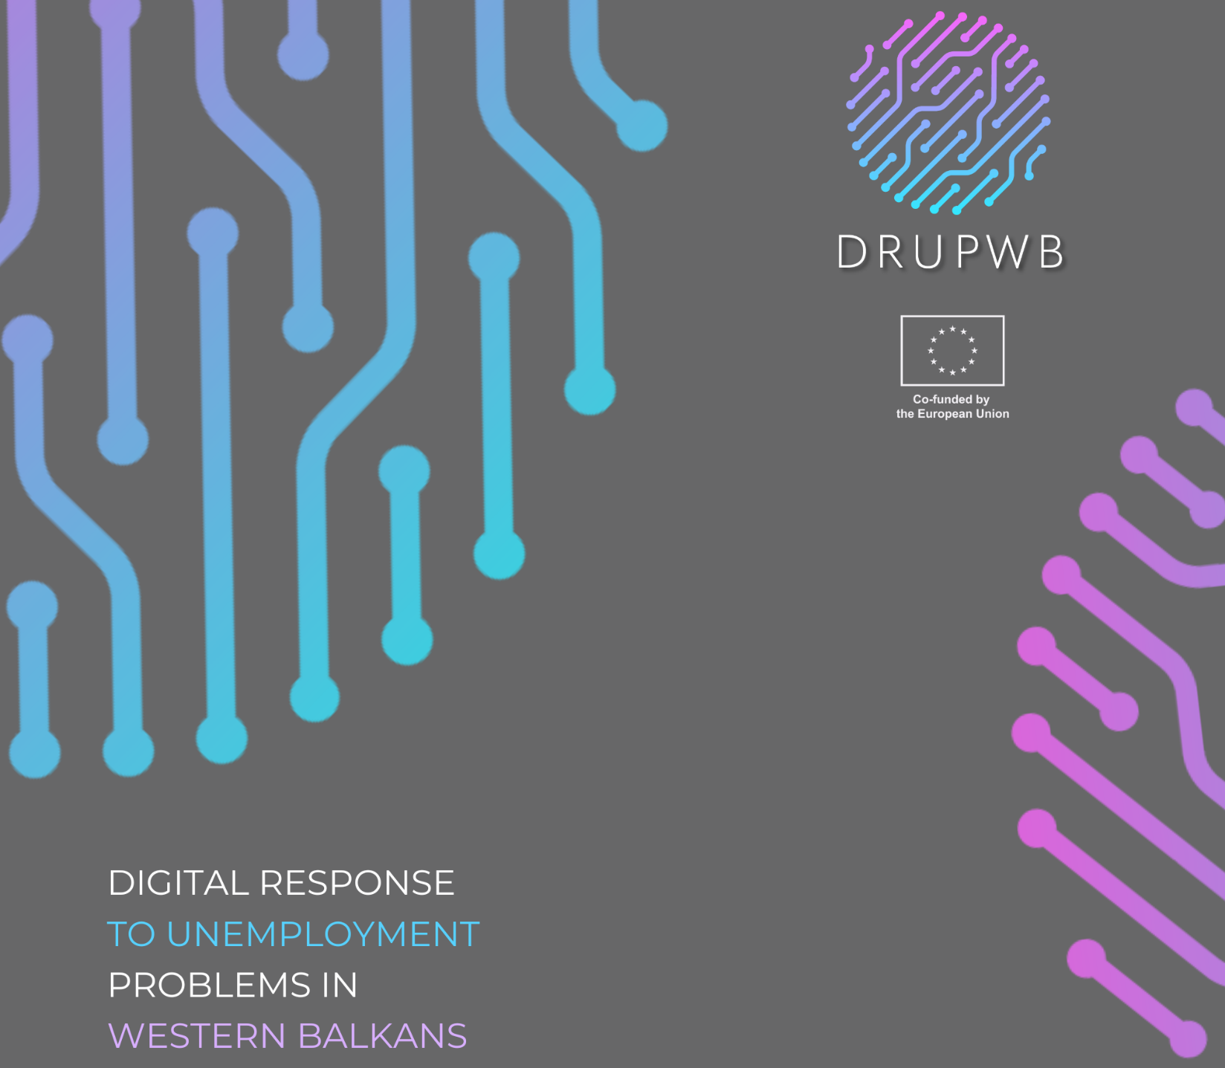

Draft Agenda for the DRUPWB project Educational Study Visit
  - Vilnius, Lithuania, March 2025

 | VILNIUS TECH |  | 2025

Dates: March 16–25, 2025
Duration: 10 days (including 2 travel days)
Venue: VILNIUS TECH "LinkMenų fabrikas," Vilnius, Lithuania
Language: English
Participants: 30 participants (5 per partner country)

Day 1: Arrival in Vilnius
- Arrival of participants
- Transfer to accommodation
- Welcome Dinner & Informal Networking Session, TBA
Day 2
Venue: VILNIUS TECH "LinkMenų fabrikas"
- 10:00–10:30 | Welcome and Study Visit Overview
  - Opening remarks and agenda presentation
- 10:30–12:00 | Tour around VILNIUS TECH "LinkMenų fabrikas"
- 12:00–13:00 | Lunch Break
- 13:00–15:00 | Workshop: VET Practices in Lithuania
  - Insights into VET systems, challenges, and opportunities
- 15:00–16:00 | Participant Presentations
  - Experiences and challenges in VET education from each country
- 16:00–17:00 | Group Reflection & Wrap-Up
Day 3
Venue: VILNIUS TECH Knowledge and Technology Transfer Centre
10:00–11:00 | Introduction to VILNIUS TECH Knowledge and Technology Transfer Centre
- 11:00–11:30 | Coffee break
- 11:30–12:30 | Lecture: TBA
- 12:30–13:30 | Lunch Break
- 13:30–15:00 | Study visits to the Sunrise Valley Science & Technology Park
- 15:00–16:00 | Wrap-Up & Reflection
Day 4
Venue: Visoriai Information Technology Park, VILNIUS TECH "LinkMenų fabrikas"
- 10:00–10:30 | Introduction of Visoriai Information Technology Park
- 10:30–11:00 | Coffee break
- 11:00–12:30 | Site Visits: Selected Startups and Tech Initiatives
- 12:30–13:30 | Lunch break
- 13:30–14:00 | Transfer to VILNIUS TECH "LinkMenų fabrikas"
- 14:00–15:00 | Workshop: TBA
- 15:00–16:00 | Wrap-Up & Reflection
Day 5
Venue: VILNIUS TECH "LinkMenų fabrikas"
- 10:00–12:00 | Workshop: TBA
- 12:00–13:00 | Lunch Break
- 13:00–16:00 | Cultural Visit: Old Town Vilnius Guided Tour
- Free Time for Participants
Day 6
Venue: VILNIUS TECH "LinkMenų fabrikas"
- 10:00–11:00 | Workshop: TBA
- 11:00–11:30 | Coffee Break
- 11:30–12:30 | Lecture: TBA
- 12:30–13:30 | Lunch Break
- 13:30–14:30 | Workshop: TBA
- 14:30–15:00 | Coffee Break
- 15:00–16:00 | Wrap-Up & Reflection

Day 7
Venue: Innovation Agency Lithuania
- 10:00–11:00 | Introduction to Innovation Agency
- 11:00–11:30 | Coffee Break
- 11:30–12:00 | Site Visit and tour around
- 12:00–13:00 | Lunch Break
- 13:00–15:00 | Lecture: TBA
- 15:00–16:30 | Networking and Follow-Up Planning

Day 8: Action Plan Development
Venue: VILNIUS TECH "LinkMenų fabrikas"
- 10:00–12:00 | Group Work: Drafting Joint Action Plans
- 12:00–13:00 | Lunch Break
- 13:00–16:00 | Presentation of Joint Action Plans
- 16:00–17:00 | Discussion and Feedback

Day 9: Summary and Farewell
Venue: VILNIUS TECH "LinkMenų fabrikas"
- 10:00–11:30 | Final Recap and Key Takeaways
- 11:30–12:00 | Closing Ceremony and Certificate Distribution
- 12:00–13:00 | Farewell Lunch
- Afternoon | Free Time

Day 10: Departure Day
- Participants depart from Vilnius

Funded by the European Union. Views and opinions expressed are however those of the author(s) only and do not necessarily reflect those of the European Union or the European Education and Culture Executive Agency (EACEA). Neither the European Union nor EACEA can be held responsible for them.

