It’s My Nature
A Training Course for Youth Workers to Improve Skills through the Power of Participatory Theatre
Based on Creativity and Inner Leadership as Tools for Social Inclusion

Saturday, September 23rd – Saturday, September 30th, 2023
(including Travel days)
Woodstown, County Waterford, Ireland
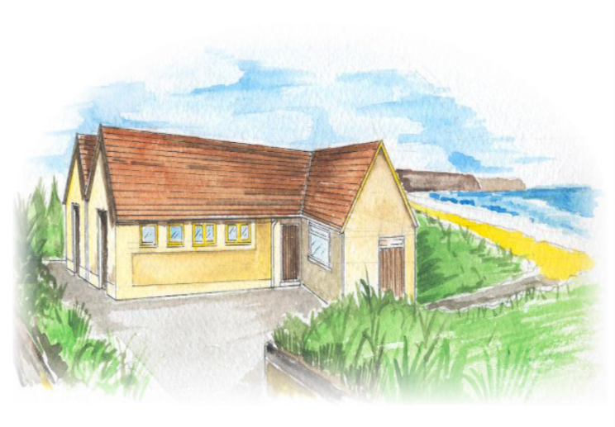
Woodstown Residential and Activity Centre (WRAC)

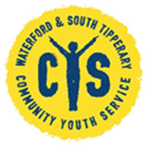
Overall Aim

The overall aim of the Training Course is to improve the self-awareness and self-confidence of Youth workers from across Europe so that they can support the young people that they work with and can guide them in their learning process as full, authentic people. The Course participants will do this through the development of a learning toolkit which they can use with their own young people in their own countries after the Course.

Objectives

- To support youth workers to become more aware of themselves, thus enabling them to make conscious choices and decisions that fit with the core of their identity and their goals in life
- To dive deeper into, and really experience concepts such as resilience, confidence, vulnerability, empathy and creativity
- To frame a learning process where youth workers feel commitment and inclusion by sharing and experience
- To provide youth workers with tools to support a deep connection with young people they work with
- To include local people with the effective method of Participatory Theatre and spread this around
- To share tools and methods from across Europe, and to inspire the participants to implement similar learning processes after the Training Course for their own target groups
- To reflect on their own learning process by using the Key Competences from the Youth Pass, and giving the opportunity for capacity building in the context of the Erasmus+ Program.

Background and Theme of the Project

Inclusion is one of the biggest challenges faced by all EU member states. The challenge of how to create a safe and inclusive Europe is a high priority in the Erasmus+ program: “Europe needs more cohesive and inclusive societies which allow citizens to play an active role in democratic life. Education and youth work are key to promoting common European values, fostering social integration, enhancing intercultural understanding, and creating a sense of belonging to a community, thus preventing violent radicalization. Erasmus+ is an effective instrument in promoting the inclusion of people with disadvantaged backgrounds.”

Youth workers are viewed as professionals for whom inclusion is an important part of their work - in particular ‘youth at risk’ is an important target group for youth workers. Young people who feel excluded and disappointed, with little confidence and self-esteem, are in danger of becoming involved with extreme groups. Youth workers deliver important outcomes with young people who have ‘dropped out’. Youth work is a vital tool to bring young people in from the cold, to connect them with society, and to develop the self-esteem and self-confidence that empowers young people to choose their own paths in life. Youth work is ‘planned, informal education’, and youth workers engage and build relationships with some of the most vulnerable young people in Europe starting where the young people are at in their lives.

In this field, where the solutions are not immediately obvious, innovation and innovative ways of working are critically important in developing professionals and organizations.
The focus of this Training Course is on the stages before the problems start, using the methodology of Participatory and Immersive Theatre, which is a proven, effective method to detect feelings, values and senses under the surface. It can be utilized as a prevention tool by stimulating feelings and commitments on a deeper level, which can help to avoid exclusion and isolation.

This European project is an opportunity to examine and reflect upon the issues around inclusion from different perspectives, to learn from different countries and cultures by sharing knowledge about new ways of working, and to clarify ideas around a common understanding of inclusion. It will also help to build a wider and better European network to tackle the challenges around how to be more inclusive within Europe.

Approach and Methodology

This Training Course will be based on non-formal and informal education with a self-directed learning approach. The trainers will use artistic tools and performances, in particular the very effective method of Participatory and Immersive Theatre to stimulate growing self-confidence and resilience.
The environment at the Woodstown Centre provides a tranquil, serene setting for this Project. The sound of the waves lapping the ocean just 10 meters from the front door; the wind quietly rustling the leaves of the native Irish trees overhead, and the abundant natural world all around – this is the backdrop for the ‘It’s My Nature’ Training Course.
Participatory theatre is an immersive, interactive, site-specific and contact-oriented theatre form. While experiencing the artwork, the sense of touch is activated more widely than just in the area of the body that rests on the chair. The spectator also becomes a listener, a sniffer, a toucher, a taster, and a thinking agent. He or she is led through different parts of space, where scenes take place. Immersive performances can be particularly effective in creating a sense of immersion and emotional connection with the audience, allowing them to become fully immersed in the story and experience it in a more visceral way. These scenes have been developed according to the attributes of the space (in this case, Woodstown beach), and by adding elements to support the scene. The scene comes to life when the spectator and the performer meet and engage each other. Participants will put on a performance for local people in Woodstown, illustrating their learnings, and showcasing Youth work. Outdoor performances provide an opportunity to connect with nature while enjoying a theatrical experience.
During this course, participants are responsible for their own learning and the facilitators provide activities, and guide the participants through their own learning process. The Training Course will be characterized by highly participatory, interactive and experiential methods. The working methods will include case studies, working in pairs and small groups, meditations, contemplations, team building activities, role plays, discussions, and self-assessment. Some sessions will be complemented by theoretical inputs, and all of them will be followed by group reflection or self-reflection.

Profile of the Participants

Participants will be youth workers, project leaders and educators involved in youth work. The participants will have a multiplier role - in other words: they will adapt what they learn in this training course to their own context of working with young people. In their future projects and daily work they can incorporate tools, methods and theories which they have learned during this Training Course. They can also use their personal learning and development in their daily work with their own target groups.
This Training Course will be an emotionally challenging project for trainers and trainees. That’s why we expect from trainees at all times to the best of their abilities to…
- be fully committed to the process - to reflect, share, experience and participate in all activities
- keep a clear mind, that is neither intoxicated nor distracted
- have taken care of important personal and professional matters beforehand, so that these do not intervene with the Training Course (being completely present with the group)
- be on time for all of the deadlines, sessions and appointments
- challenge themselves to step out of their comfort zones
- be willing to look into themselves and reflect on their professional and private life
- join us on an intensive, immersive and unforgettable journey

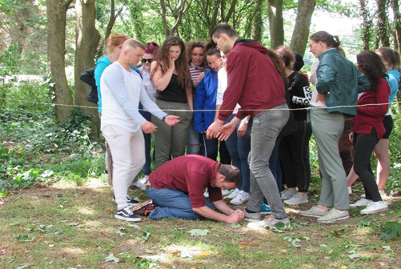

The Process of ‘trusting the process’
Outline of Schedule

This following schedule is intended to give participants an outline of the week’s activities, and is subject to change, depending on the needs of the group.

Timetable | Activities
Day 1 (Saturday) | Arrival of participants and a Welcome evening; Getting to know each other
Day 2 (Sunday)
Am | Opening the Course and getting to know needs and expectations; Youthpass introduction; Group management guidelines; Team-building
Pm | Inner Leadership and River of Life exercises; Reflection groups
Day 3 (Monday)
Am | Vulnerability workshop
Pm | Power of Silence exercises
Day 4 (Tuesday)
Am | Kinetic and Body expression session
Pm | Trip to mountains and beaches of County Waterford
Evening | Traditional music session
Day 5 (Wednesday)
Am | Resilience – Compassion and Gratitude
Pm | Immersive Theatre preparations
Evening | Intercultural evening
Day 6 (Thursday)
Am | Immersive Theatre preparations
Pm | Immersive Theatre preparation
Evening | Outdoor Participatory Performance
Day 7 (Friday)
Am | Participatory Theatre - debriefing and deep reflection
Pm | What can Erasmus+ do for you? Capacity building and making decisions;  Transitioning and Accountability; Self-assessment and Evaluation
Evening | Farewell party and bonfire/Barbecue on the beach
Day 8
(Saturday)
Am | All participants and facilitators depart

More about the Trainers

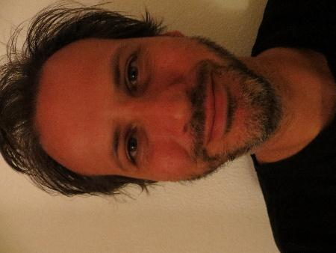
Dominique Verschuren: His expertise is Inner leadership and non-formal learning. Dominique believes that awareness and a practical understanding of our identity serves all of our relationships, learning experiences and talent development. He delivers high quality Training Courses using innovative activities and coaching methods, building real commitment with the participants, giving attention to ambiguity. Topics: vulnerability and confidence, powerless feelings and resilience, transition and accountability, timing, curiosity and creativity.

Elena Serrano: Professional actress and musician, she works as a trainer using applied theatre techniques such as the Theatre of the Oppressed, Immersive Theatre and Labyrinth Theatre. Elena believes that play is an innate instinct and every human being is theatre; we produce actions and observe those actions and their effects on the outside world. Topics: presence, space, imagination, sensorial experience, self-consciousness and collective creation.

Practical & Travel information

Venue
The Training Course will take place at:

Woodstown Residential and Activity Centre (WRAC), Woodstown Beach, Co. Waterford, Ireland (X91FX29)
Telephone: 00 353 86 3889723 or 00 353 51 309364
Email: woodstown@wstcys.ie

WRAC is a Project of the Waterford and South Tipperary Community Youth Service, based at the Edmund Rice Youth and Community Multiplex, Manor St., Waterford City, Ireland

The Centre is situated on the beachfront around 10km from Waterford City – it offers tranquility and privacy in a quiet rural area, and is set on 2 acres of its own grounds.
The accommodation is mainly aimed at sharing the space as one large group. Keep this in mind when you decide to join this TC. Practically this means:
- The Centre operates on a self-catering basis, and has bunk-bed type accommodation for up to 32 people.
- Please note that the sleeping space involves two shared 16-person dormitories. So you share the sleeping room with many other people!
- There is a fully equipped kitchen, a large dining room, a living room and a TV/Training room with a fireplace.
- Bed linen, duvets and pillows are provided, but you will have to bring your own towels and toiletries (soap, shampoo, toothpaste, etc.).

Meals
All food will be provided by the organizers, either at the venue or in the restaurant next door. It will be self-catering for breakfast and lunch, and dinner will be provided. (NB. If you have any allergies, or other dietary requirements, please let us know)
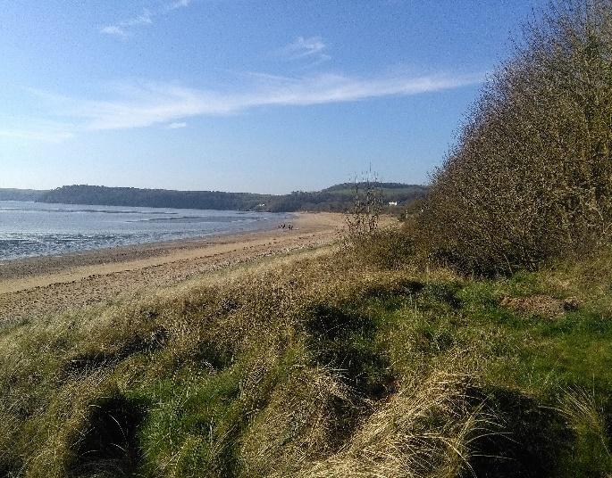
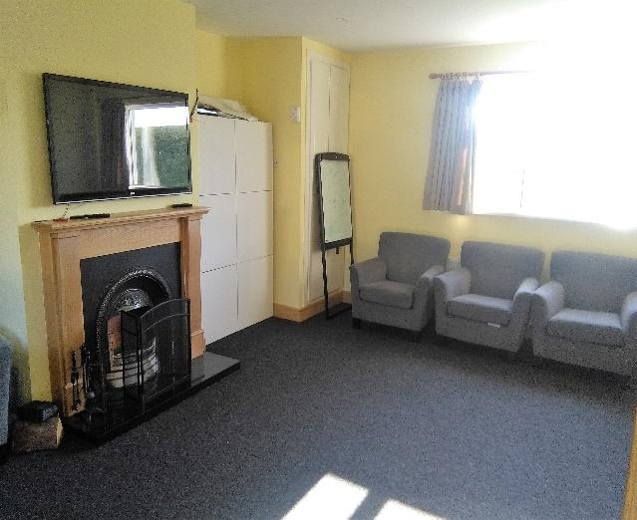
WRAC Training Room Woodstown Beach

When & How to Get There:

Participants are responsible for booking their own travel – it’s up to the partner organizations to support them in the process.
Depending on where you’re travelling from, the two closest airports are Dublin and Cork, which are both around two hours travelling time from Waterford City. You can take either a train or a bus from Dublin Airport (www.irishrail.ie, www.buseireann.ie, www.jjkavanagh.ie) but only a bus from Cork (www.buseireann.ie).

If you let Declan know what time you’ll be arriving into Waterford City, he’ll arrange to collect you and transport you to Woodstown.

Other Practical Details:

- We will be taking ALL relevant Covid-19 precautions at all times
- Participants will be accommodated in bunk beds in shared, dormitory-style rooms.
- There is a wireless internet connection available at the venue
- The weather in Ireland is ‘changeable’. Don't forget your umbrella, as there might be rain, but you might also need sunscreen. Half the fun of being in Ireland will be guessing the weather! You can follow the weather forecast here: http://weather-finder.com/Ireland/Waterford/
- The currency is Euro. If you need to change money: Please use the Airport Exchange Office.
- Insurance: Insurance is each participant’s responsibility. You need to have travel insurance and the European Health Card.
- Working language Working language of this training course is English. Don’t be afraid, your English doesn’t need to be perfect, neither is ours! What is important is that your English is good enough to actively participate.
- Contact details in case of emergency If you are ever in any trouble, you can call Declan at 00 353 86 3889723

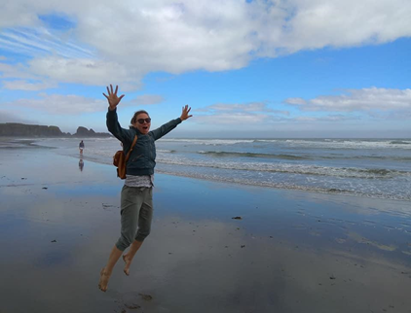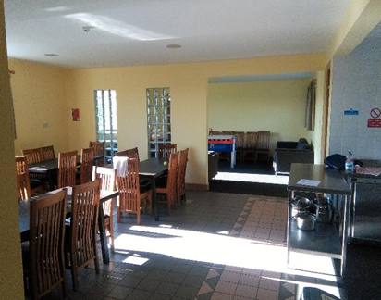
The Copper Coast WRAC Dining Room
Financial Considerations:

- The food and accommodation will be completely provided and paid by Erasmus+.
- Visa costs (if needed) will be reimbursed by the organizers after the Training Course, once receipts are received.
- Travel costs include plane, train or bus costs from your home country to Woodstown.
- ALL costs must be receipted.

Reimbursement of travel costs:
Travels costs (plane, train and bus) will be counted by distance calculator provided by European Commission and reimbursed by bank transfer directly to the participant within 4 weeks of the Course finishing. The reimbursement is determined by the Erasmus+-guide.
The participants have to give the receipts for the travel costs to the organizers. The reimbursement will be made through bank transfer after the training course after Waterford & South Tipperary Community Youth Service have received the travel tickets.

Communications:

Contact us anytime if you have any questions, concerns or feedback.
Let us know of any changes that are relevant to the running of the Training Course as soon as you can, such as:
- Your (non) participation in the course
- All travel related issues, including costs and the exact itinerary
- Your contact details
- Anything else we need to know for a smooth functioning of the Training Course – all information will be treated confidentially

Remember, we’re here to help you out in any way that we can, and to ensure that you enjoy your time in Ireland. We want you, your organization, and most importantly the young people you work with, to get a significant benefit from attending the Training Course, so if there’s anything we can help you with or any question that we can answer, just ring Declan on 00 353 86 3889723 or email at woodstown@wstcys.ie

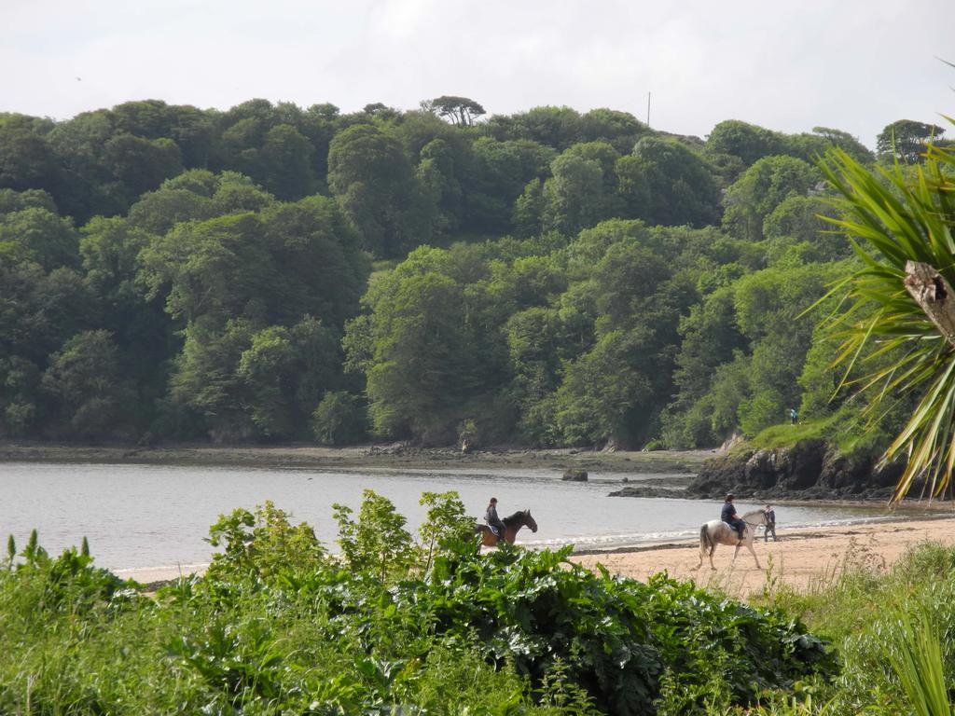
Woodstown Beach, County Waterford

