[DJS/Langue (2005) 1]

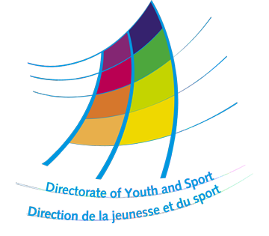

Quality Development and Support Measures

Language Course Programme

Language and intercultural learning empowering youth workers
in Europe

European Youth Centre, Strasbourg
30, rue Pierre de Coubertin
F - 67000 Strasbourg, France
Tél : +33/ 3 88 41 23 00 - Fax : +33/ 3 88 41 27 77/78
E-mail : anne.dussap@coe.int - http://www.coe.fr/youth

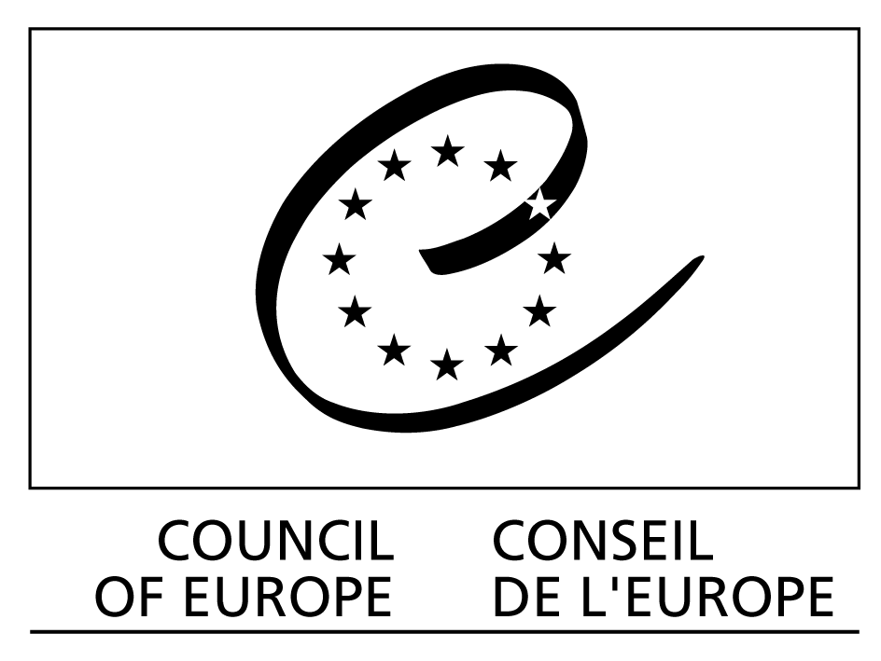
Programme
and
application form
Language Course Programme 2005
Why language courses?
Foreign language skills and intercultural competence are essential preconditions for youth mobility and for the development of international activities. It is for this reason that the Directorate of Youth and Sport has traditionally organised language courses for young people active in international youth work and youth activities. The language course programme is a fundamental instrument in the development of youth policy at European level. Since the first English language course was organised in 1966, educational approaches in the context of language learning have evolved in response to the specific needs of youth organisations in the development of youth activities at European level. The intercultural language courses have developed into language training courses integrating language learning, intercultural learning and the discovery of European youth work. The methodology developed over the years is adapted to youth work realities and combines language learning and intercultural learning as well as individual and group learning. In this sense the language course programme forms an important pillar of the “Quality Development and Support Measures” programme proposed by the Directorate of Youth and Sport for 2003 to 2005.
Learning a language differently: more than a language course
The intercultural language courses of the Directorate of Youth and Sport offer more than just language lessons. They provide for the overall development of language and intercultural competence adapted to youth work through:
  - classroom sessions using a variety of materials and activities relevant to youth work and the participants’ needs and interests; these sessions provide for practice in the skills of listening, speaking, reading and writing as well as for developing knowledge of grammar and vocabulary;
  - periods of individual study during which participants can use language centre resources to practise specific skills and consolidate learning;
  - workshops related to international youth work
  - contact with local youth organisations;
  - a programme of visits.

The various course elements aim at providing participants with communication skills in the target language adapted to youth work activities and with the skills to continue learning the language and developing intercultural attitudes after the courses. The courses use a methodology which is developed around participants’ initiative. Course teams function as consultants for learning. Participants are encouraged to take responsibility for their own learning.

The aim of the language courses is to enable members of youth organisations to become more active in international youth work by improving their language and communication skills in the context of European youth work.

The main objectives are:
- to improve the participants’ general and specific language knowledge and skills (using themes and terminology linked to youth work);
- to enable participants to discover the political, social and cultural life of the host country;
- to allow participants to familiarise themselves with the different aspects of youth work at local, national and international level;
- to encourage networking amongst European youth associations;
- to promote youth mobility, intercultural attitudes and multilingualism in youth work.

Who are these courses for ?
The intercultural and language courses should be seen as an opportunity for youth organisations to provide training to their members for the development of international youth work. Candidates, therefore, have to be nominated by their organisation, which will justify their choice on the basis of the importance of the participation of the candidate in the intercultural language course for the projects or activities he/she is carrying out within the organisation or for the development of the organisation at European level. The nominating organisations have to make an initial selection from the applications they receive from their member organisations and will propose only two candidates in order of priority per course. The participants chosen should be aware of the importance of their participation in the language course for the development of his/her organisation and provide the nominating organisation with a report about the course within two months after the course.

Profile of candidates
  - actively involved in youth work, in a youth organisation or a youth network, preferably in a field of international co-operation or be commited to take on responsibilities at international level;
  - aged between 18 – 30;
  - well informed about their local organisation and the international / national sending organisation (participants should be able to present their organisations and activities to the other participants);
  - highly motivated to benefit from the course by participating in all activities and to contribute to the development of the programme and to the group process
  - willing to work in a group, to take initiatives and to share with others.
All these conditions are strictly applied.
The participants’ motivation and learning needs for their youth work activities are considered as the most important criteria for the selection. These courses require initiative and active participation.

These courses are not not suitable for complete beginners,
a minimum level of the language is required

Those who have already participated in a Directorate of Youth and Sport language course are not eligible to re-apply.

How to apply
Applicants must be nominated by the youth organisation in which they are active. The nominating organisation should be connected with one of the following types of youth organisations or structures (see Part I of the candidate’s application form):
  - International Non-Governmental Youth Organisations,
  - National Youth Council,
  - National Agencies for the YOUTH programme of the European Union
  - With the CDEJ, (European Steering Committee of Youth) local, regional or national authority, Ministry, municipality, etc.

Applicants should send the completed applications to their organisations (see Part I of the application form) at the latest by the 1st of March 2005. The nominating organisation will make an initial selection and nominate up to two candidates in order of priority for each language course.

No applications will be accepted after the deadline. Incomplete or unreadable forms will be rejected.

Selection criteria:
When the Directorate of Youth and Sport has received the nominations of the sending organisations (deadline 15st March), the participants will be selected according to the following criteria :
    - Priority given by the organisation
    - The responsabilities of the candidate in youth work determined by the projects and activities described by the candidate in his/her application form, which will be also annotated by the nominating organisation.
    - Relevance of the candidates projects and activities for the priority areas of the Directorate of Youth and Sport

Priority will be given to disadvantaged candidates who would not have any other possibility to learn a language.
Conditions of participation:

Travel expenses: The cost of travel to and from the course is to be paid by the participant;

Aid to cover travel expenses for disadvantaged young people: In order to encourage the participation of disadvantaged young people, the Directorate of Youth and Sport has created a special Fund to partly cover travel expenses of young people who can not afford to pay the costs of the journey. This Fund is limited and will comprise only 10% of all the participants to the courses. A request, justifying why the candidate should be considered as a disadvantaged person, has to be sent by the participants after having received the confirmation of his/her participation to the course. This request will have to be supported by the nominating organisation.

Enrolment fees:

Board and lodging as well as tuition costs are provided and paid by the Council of Europe and, in most of the cases, by the governmental authorities of the hosting country. An enrolment fee of
€ 100 per participant will have to be paid in cash by the participant during the language course to the course organiser.

While all expenses (board and lodging, educational costs) for full participation in the courses are covered by the Council of Europe and the national authority hosting the course, no pocket money for other activities is available. Participants should take note of information offered by individual courses on local costs and make provisions accordingly.

Your attention is drawn to the fact that there are very few places for a high demand; therefore, when a candidate knows that he/she has been selected to participate, the candidate must commit to attend for the full duration of the course, and that if, for any reason, the candidate is unable to take up the offer of a place, he/she must immediately inform the Directorate of Youth and Sport and the sending orgnaisation. This is also the case for applicants placed on the waiting list.

Time schedule for the selection of participants:

1st March | Member organisations send back their applications to the headquarters who will select two candidates per course and send the selected applications to the Directorate of Youth and Sport
15th March | Deadline for reception of the selected applications by the Directorate of Youth and Sport (applications sent by mail or fax – NOT e-mail)
20th April | Information about the selection to the youth organisations and applicants
31th April | Confirmation from the participants and applications for the refund of travel costs
Before the course | Participants should contact their headquarters to organise their travel / visa and to get information about their international / national organisations
 | COURSE
After the course | Report written by the participants sent to the sending organisation within two months

Language course programme

English language courses

- English language course - Ireland
Dates: 03-30.07.2005 (to be confirmed)
(30 participants)

French language course

France / European Youth Centre, Strasbourg
Dates: 14.08 – 10.09.2005
(35 participants)

Russian language course

Russian Federation / Moscow
Dates/ 26.06 – 23.07.2005
(20 participants)

Spanish language course

Spain / Mollina - CEULAJ, Centro Eurolatinoamericano de Juventud
Dates: July 2005 (dates to be precised)
(15 participants)

German language course

Germany / Europa Kolleg, Kassel
Dates: 31.07 – 27.08.2005
(26 participants)

Italian language course
Italy / Instituto Trentino di Cultura, Trento
Dates: 19.06 – 09.07.2005
(20 participants)

For the definition of “disadvantaged” see the definition given for the Mobility Fund (http://galadriel.coe.int/fsmj/portal/media-type/html/user/anon/page/FSMJ_presentation;jsessionid=FDF16A4DD5D4EF5327D70BE26CA9BD6C)

