YOUTH Programme
Application Form
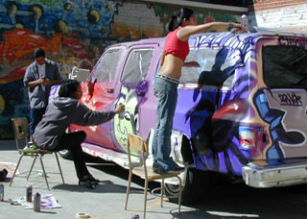
STREETWISE!
A TRAINING FOR YOUTHWORKERS WHO WANT TO MAKE YOUTH IN ACTION A TOOL FOR INCLUSION.

www.joc-ysselsteyn.com

ysselsteyn, The Netherlands
12th – 15th of March 2009

.

PART I
Please type or write in capital letters
First name:
Family name:
Date of birth:
Sex (f/m):

Private address:

Street and street number:

Postal code and place:

Country:

Tel:
E-mail:

Work address:

Name of the organisation:

Street and street number:

Postal code and place:

Country:

Tel:
Fax:
E-mail:

Your previous experience in (international) youth activities:

YOUR FUTURE PLANS WITH THE YOUTH IN ACTION PROGRAM? PLEASE EXPLAIN.

Language proficiency:

Spoken Written

English: fluent/fair/poor fluent/fair/poor
Any other: ………………. fluent/fair/poor fluent/fair/poor

Please, indicate special needs and requests (diet, Vegetarian, Health, Disabilities, etc.):

PART II

Brief description of your organisation´s activities:

Activities of YOUR organisation in relation to international youth work:

Activities of YOUR organisation in relation to SOCIAL INCLUSION:

What is your position in the organisation?

YOUR EXPERIENCES IN WORKING WITH GROUPS OR YOUNGSTERS FROM A VULNERABLE BACKGROUND?

YOUR MAIN GOALS CONCERNING SOCIAL INCLUSION FOR THIS TRAINING? (your learning goals)

Any other comments:

DECLARATION:
Please take note of the following conditions which will apply if you accept a place on the training.

- Obtaining a full travel insurance policy is the participant's responsibility
- My correspondence address and information about my organisation, and work can be shared with the other participants as part of the course material and for other non-formal youth work related issues.
- I understand that providing the above information on special needs does not remove my own personal responsibility for ensuring my own safety.

Signature: Place: date:

Please, return this application form to your YOUTH National Agency before the

