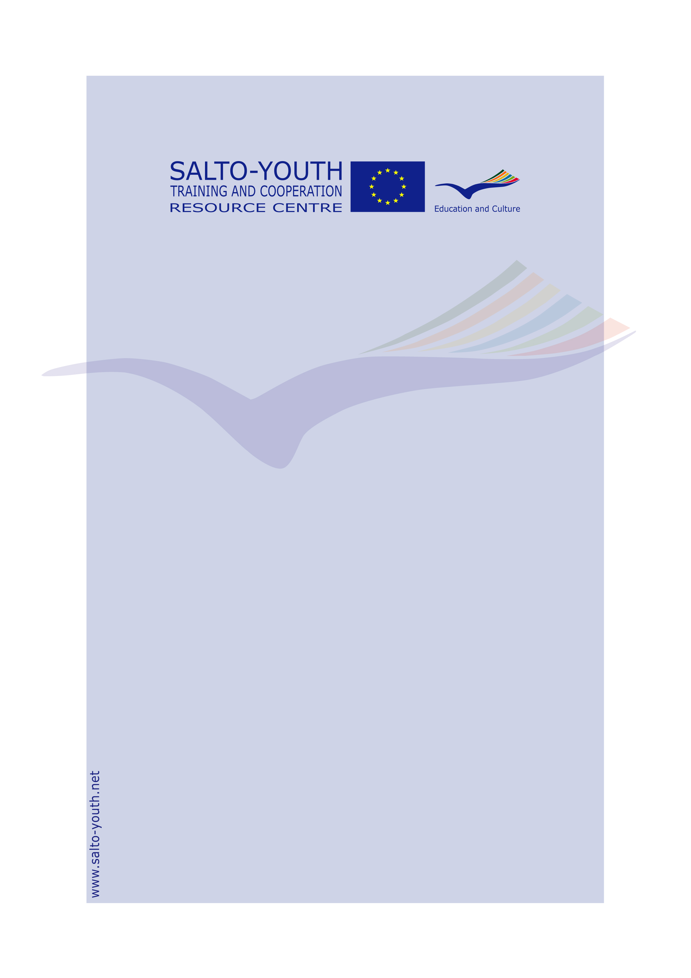

BiTriMulti
Training Course

Info Pack

for

PARTICIPANTS

Info Pack for Participants
about BiTriMulti Training Course
Season 2007-2008

BiTriMulti Training Courses (further in the document BTM )
Co-ordinated and monitored by the SALTO Training and Co-operation Resource Centre
Organised by the network of National Agencies for the Youth in Action Programme
Financed by the Youth in Action Programme of the European Commission

BTM Info Pack for Participants compiled and edited by
the BTM trainers pool:
Jo Claeys
Gerald Dowden
Elizabeth Kasa
Nerijus Kriauciunas
Sandra Siere
Claudia Vella
Wim Vogelaere

in collaboration with
Tanja Kaltenborn, SALTO Training and Co-operation Resource Centre

Published by
the SALTO Training and Co-operation Resource Centre
c/o JUGEND für Europa – German Agency for the EU Programme YOUTH IN ACTION
Bonn, June 2007

PARTICIPANT PACK

BTM TRAINING COURSE

DEAR PARTICIPANT,

We are looking forward to meeting you and to working with you in the international training course BiTriMulti (further in the document BTM) on how to tackle all of the basic elements of organising an international Youth Exchange under the Youth in Action Programme. It will be a learning-by-doing experience for you, built on a simulation exercise.
In this training course you might find new partners, BUT THIS IS NOT THE MAIN OBJECTIVE OF THE TRAINING COURSE.

ABOUT THE YOUTH IN ACTION PROGRAMME
We kindly ask you to bring this BTM Info Pack for Participants with you, which includes a brief explanation of the European Youth in Action Programme focusing on Youth Exchanges (Action 1.1). You can find more information about the Youth in Action Programme at http://ec.europa.eu/youth/yia/index_en.html or at the web site of your National Agency (please contact them for further information).

IN THIS PACK YOU FIND:
- The day-by-day programme of your training course (the programme is flexible and may be changed),
- A brief presentation of the European Youth in Action Programme with a focus on Youth Exchanges (Action 1.1.)

ABOUT YOUR ORGANISATION
Please bring clear information (printed information, leaflets, booklets, or any other relevant material) about the main activities of your organisation to present the profile of your organisation to the other participants in the BTM training course. Note that you will not be asked to present your organisation in front of the other participants in an oral way or using a computer-assisted presentation during the official programme. However, you might be able to do so during the informal moments of the training course and if any of the participants would be interested in listening.

ABOUT YOUR COUNTRY/REGION/TOWN
Please bring a map, posters, postcards, leaflets, etc. Please think as well about how to present your country and culture.
An evening will be organised when each country group has the possibility to present themselves and their country (up to 5 min.). Please note that, if you bring videos or computer presentation with you, you will only be able to watch and show them during your free time, which is sparse, and in case the other participants would like to learn more.

LAST BUT NOT LEAST…
…we remind you to bring gastronomic specialities from you region or country: food (it may be possible to heat food, but not to cook it at the training centre) and drinks for an “intercultural evening”.
Bring CDs of traditional/typical and party music or other things typical from your country that you want to share with us during the intercultural and other evenings. Bringing with you different games to be used during informal moments is not forbidden!

For further information (e.g. practicalities of your BTM TC), please contact your National Agency.

Best regards and a big smile (it is compulsory to bring it with you, too!!!),
the BTM trainers and National Agency team

PARTICIPANT PACK

BTMT RAINING COURSE

BRIEF DESCRIPTION OF BTM TRAINING COURSE

1. TARGET GROUP
The training course is designed for voluntary and professional youth workers working directly with youngsters who are interested in setting up international exchange projects. The focus remains on training and not on partner finding.

It doesn’t matter whether you are just interested in doing a Youth Exchange or are definitely planning to do an exchange, as long as you are not experienced in doing Youth Exchanges under the Youth in Action Programme. If you represent an organisation or group with little experience but you see that you could still benefit from the input of a BTM training course, you can still participate, being aware that the course is mostly on setting up an exchange.

We chose a short-term training course, because it is easier to find the time to go on a short-term training course, especially for people working on a voluntary basis.

2. AIM AND OBJECTIVES
The aim of the BTM training course is to offer an international learning experience to practitioners active in the youth work field, enabling them to develop their competencies in setting up quality Youth Exchange projects under the Youth in Action Programme.

Objectives of BTM:
- To provide an informed introduction to the Youth in Action Programme, focusing on Youth Exchanges and their capacity to enhance active (European) citizenship, especially (though not exclusively) for newcomers to the programme;
- To offer an individual and group learning experience through a simulated process on setting up a Youth Exchange project;
- To develop the necessary knowledge, skills, and attitudes to organise a Youth Exchange, based on the non-formal learning practice, principles, and quality standards of the Youth in Action Programme;
- To enable participants to reflect on their learning and to familiarise themselves with Youthpass – the strategy on the recognition of non-formal learning in the youth field, its technical tool to produce Youthpass Certificates, and its application in Youth Exchanges in particular and the Youth in Action Programme in general;
- To offer the opportunity to meet possible partner groups and to make contacts in other countries.

The main aim is to train people and a sub-goal is to offer the opportunity for participants to find partners. Other things, like getting to know other youth realities, are not an aim, but a (nice) side effect.

3. THE PROGRAMME
The BTM programme is built around a simulation game, which is interspersed with info sessions as well as activities to improve the group dynamics, and ends with an evaluation.
On the next page you find the programme of the course.
PROGRAMME
BTM TRAINING COURSE

DAILY BTM PROGRAMME FOR PARTICIPANTS
Day 1 |  | Day 2 |  | Day 3 |  | Day 4 |  | Departure day
16.00  17.00 |  | 08.00 | Breakfast | 08.00 | Breakfast | 08.00 | Breakfast | Departure of participants and the team
16.00  17.00 | Arrival of participants and WELCOME!  BTM check-in | 09.30  10.30  11.00  11.30  12.00 | Entrance to intercultural course  Intro to the course & Simulation Game  Break  Entry into the Youth in Action Programme  Simulation Game 1:  Partner request | 09.30  10.00  12.00 | Intro to the day  Simulation Game 4:  Partner meeting  Debriefing  Info about Advanced Planning Visit and Feasibility Visit | 09.30  10.00  11.00  11.30 | Intro to the day  Participation towards (European) citizenship  Break  Feedback on the applications | Departure of participants and the team
16.00  17.00 | Arrival of participants and WELCOME!  BTM check-in | 13.00 | Lunch | 13.00 | Lunch | 13.00 | Lunch | Departure of participants and the team
16.00  17.00 | Arrival of participants and WELCOME!  BTM check-in | 15.00  16.30  17.00  18.30 | Simulation Game 2:  Partner finding  Break  Matching groups  Debriefing  Info about partner finding  Simulation Game 3: Preparation for partner meeting | 14.30  16.00  16.30 | Simulation Game 5:  Application  Debriefing  Break | 15.00  17.00  17.30 | Info market on Youth in Action: info on programme, Youthpass & quality demands  Coffee break  Evaluation of the training course  BTM check-out | Departure of participants and the team
19.00 | Dinner | 19.00 | Dinner | 20.00 | Dinner | 19.00 | Dinner | Departure of participants and the team
20.00 | Getting to know and group dynamics | 20.00 | Intercultural evening |  |  | 20.00 | Good-bye evening | Departure of participants and the team

PARTICIPANT PACK

BTM TRAINING COURSE

THE EUROPEAN YOUTH IN ACTION PROGRAMME
The European Commission, the European Parliament and the Member States of the European Union have agreed on establishing the Youth in Action Programme for the period of as from 2007 to 2013. Youth in Action is the EU programme in the field of youth, which provides young people with opportunities for non-formal and informal learning with a European dimension.

AIM
The Youth in Action Programme encourages the concept of Livelong Learning and is aimed at inspiring a sense of European Citizenship among the youth of Europe and at involving them in constructing the future of the community.

OBJECTIVES
- Promote young people’s active citizenship in general and their European citizenship in particular;
- Develop solidarity and promote tolerance among young people, in particular in order to foster social cohesion in the European Union;
- Foster mutual understanding between young people in different countries;
- Contribute to developing the quality of support systems for youth activities and the capabilities of civil society organisations in the youth field;
- Promote European co-operation in the youth field.

ACTION 1 | 1.1 YOUTH EXCHANGES

1. WHY HAVE YOUTH EXCHANGES?
Youth Exchanges are intended to contribute to the personal development of the young participants. The exchanges are open to all European young people, regardless of their background, education, or socio-economic situation.

2. DEFINITION
A Youth Exchange brings together groups of young people from two or more countries, providing
them with an opportunity to meet, discuss, and confront various themes, while learning about each
other’s countries and cultures. The main aim is to encourage and promote the personal and social
education of young people, reinforcing their feeling of being European citizens.

3. TYPES OF ACTIVITIES
- Bilateral (one-to-one) exchanges; i.e. one sending & one host organisation
- Trilateral exchanges (involving partners from THREE Programme countries)
- Multilateral exchanges (involving FOUR OR MORE Programme countries)

4. WHO ARE THE PARTNERS IN A YOUTH EXCHANGE?
Each Youth Exchange has a host group and one or a number of sending groups. The first step is to form a group which will develop the project idea. The second step is to identify partners for the future exchange.

5 WHERE CAN THESE YOUTH EXCHANGES TAKE PLACE?
Youth Exchanges may take place in countries which are eligible to participate in the Youth in Action Programme – 27 Members States of the European Union, 3 members of the European Economic Area and 1 country candidating for accessing the European Union. In the ‘Programme Guide’ you find a list of all the Programme countries. At least ONE of the groups involved in the Youth Exchange project must come from a European Union Member State.

6. WHO CAN PARTICIPATE?
Groups of young people between 13 and 25 years old who reside in a country eligible to participate in the European Youth in Action Programme, young people from less privileged cultural, geographical, or socio-economic backgrounds, and young people with disabilities.
The eligible total number of participants in one Youth Exchange project is minimum 16 and maximum 60, not including in this number group leaders.

7. DURATION
The duration of the exchange activity itself is from 6 to 21 days, including travel days.

8. AN EXCHANGE IS NOT…
• Business meetings of a youth organisation
• Holiday travel or tourist tour
• Language courses
• School/class exchanges (i.e. exchanges based on formal curricula)
• Study and/or performance tours
• Participation in a festival
• An activity which aims to make financial profit

9. HOW IS A YOUTH EXCHANGE PROJECT FINANCED?
The Youth in Action Programme grants are based on the principle of co-funding, with other public and/or private contributions (in cash, in kind, or both) and/or through fundraising activities undertaken by the young people. The total costs of a project cannot be covered by the Youth in Action Programme alone.
The Youth in Action Programme covers part of the costs of the exchange. The grant is calculated on the basis of real costs for travel and fixed rates for all related costs. The exact amounts are detailed in the application forms.
You can get information about ‘How is the grant calculated?’, ‘How to apply?’, or ‘When to apply?’ from your National Agency or from the ‘Programme Guide’ of the Youth in Action Programme. Web site of the European Commission: http://ec.europa.eu/youth/yia/index_en.html

10. YOUTHPASS
Every participant is individually entitled to receive Youthpass which confirms participation and validates the non-formal learning experience. This document can be of great benefit for the future educational or professional pathway of the participant. Through Youthpass the European Commission ensures the Youth Exchange activity is recognised as an educational experience and a period of non-formal and informal learning.

