 | 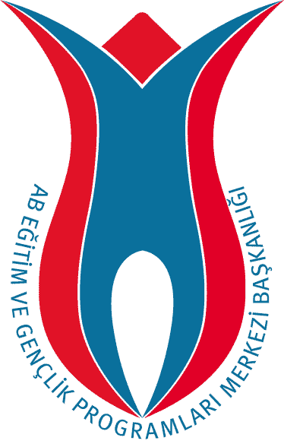
 | TURKISH NATIONAL AGENCY

Training Course on Intercultural Dialogue organized by SALTO-Cultural Diversity and Turkish National Agency
From 13th to 17th of February 2008 in ……………….. TURKEY
Application form
Deadline for applying is the 8th of January 2007

Please NOTE !
This course is open for applicants resident in one of the Youth in Action Programme countries only (27 EU countries + Iceland, Liechtenstein, Norway, Turkey).
The National Agency of the YiA Programme of your country of residence needs to support your application (and also cover your travel expenses). Therefore it might be wise to contact your NA before applying to see if they support participants to the Intercultural Dialgoue Seminar (this depends on national strategies and available funds).
* * Find a list of NAs at http://ec.europa.eu/youth/contact_en.html * *

Name |  | Surname
Name and address of the organisation / the group of young people you are representing
Your role in the organisation/group
Phone of your organisation/ group | Fax of your organisation/ group |  | Email of your organisation/group
Private Address (to be used for all course correspondence)
Private Phone (& Mobile phone) |  | Private Email
Date of Birth | Sex (M/F) |  | Nationality
Special Requirements (Mobility, Medical conditions, Diets, Restrictions, etc)
Please indicate your English skills (fluent, good, basic, poor) |  | Which other languages can you work in ?

Motivation & Background
Describe shortly but clearly what is your motivation and background to allow the National Agencies and the course team to see your link and relevance to the Intercultural Dialogue Seminar and international youth projects.
What is your motivation to take part in the Intercultural Dialogue Seminar? Why are you applying? What do you hope to get out of it?

What is your experience in intercultural dialogue projects? What good practices can you share?

Do you have any idea how to use 'Intercultural Dialogue' dimension in Youth in Action projects? Please describe:

Your skills and knowledge before the Course
Please complete these questions about what you already know, or what areas you are interested in increasing your knowledge/skills/awareness. Please tick a box 1 - 6: 1 is lowest and 6 is highest. After you have scored a number, please write a short comment to explain. * * These same questions will be asked at the end of the course and 3-6 months after the course, to see if your skills and knowledge have changed due to the seminar experience!
Rate your knowledge of the YOUTH (in Action) programme.
1 2 3 4 5 6
Comment on your knowledge:

How do you rate your own intercultural competence (working together with people from different culture)?
1 2 3 4 5 6
Please explain.

What is your knowledge on how to help young people learn to participate?
1 2 3 4 5 6
Comment on your knowledge:

What is your understanding of more/new approaches to include young people with fewer opportunities?
1 2 3 4 5 6
Comment on your knowledge:

How aware are you of being a European citizen? Comment:
1 2 3 4 5 6

What is your commitment to developing international projects? Please write a short comment about your commitment
1 2 3 4 5 6

Special needs
Please let us know if you have any special needs or requirements that the Turkish NA would need to cater for, if you are successful in being allocated a place on this seminar:
The accomodation during the activity will be in twin rooms. Please specify any reason why you would need a single room (if any). Leave this field blank if you dont mind sharing a room with someone from same sex.

Emergency contact person. Please give NAME, PHONE NUMBER and EMAIL of your emergency contact. Include the country codes (eg +44 for UK).

Comments
Write any important comments or questions that you have here. If you need a VISA for Turkey, enter your passport details here. If there is other important information that you think we might need, please write it here.
Write your comments (if any) below:

Do you need an invitation letter for a Visa to Turkey?
no yes

Disclaimers & Agreements
SALTO and the Turkish NA can use your contact details for the participant list? (for your course colleagues, NA, SALTO)
SALTO and Turkish NA can use pictures taken from the Intercultural Dialogue Seminar in which you are depicted? (for publications, website,...)
I agree that the information in this application is correct and sincere and that I will inform SALTO of any change in my application/participation immediately
I know that I am responsible for my own travel documents and health insurance, and that by providing the above information on special needs does remove my responsibility for my own health and safety
If I do not participate in at least 80% of the course, then I will forfeit my travel reimbursement from my National Agency or SALTO

