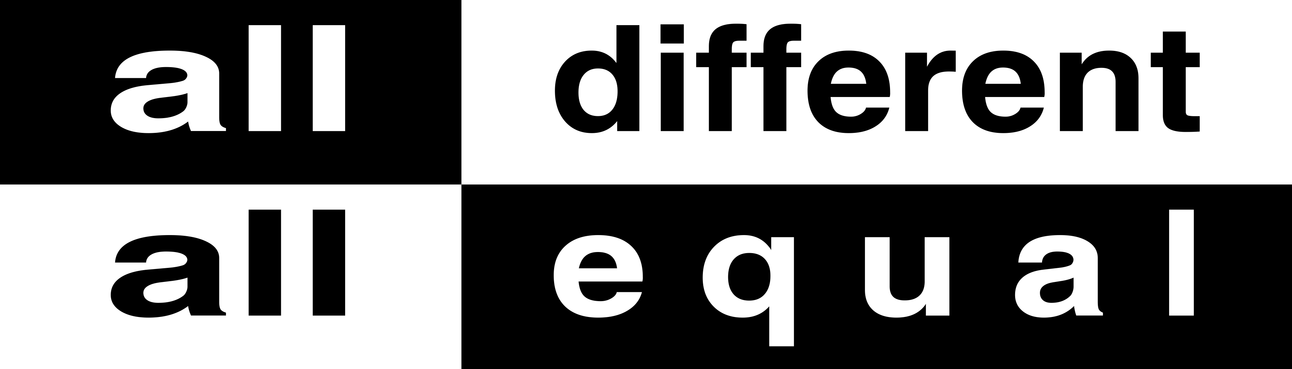
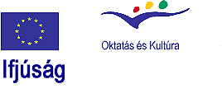
Long – term training course
„Step into colourful societies“
– training course of multipliers on cultural diversity in the local and regional youth fields
2007 - 2008
1st Training course: 13th – 23rd April, 2007 in Szeged, Hungary
2nd Training course: November 2007

Overall aim of the LTTC
Overall aim is to train youth workers, youth leaders on being able to multiply human rights in the youth field emphasis on cultural diversity with active participation of young people using non formal methodology and modern technologies. To raise awareness and develop attitudes in connection with cultural diversity, to develop understanding and skills towards using non formal methods within human rights education in local, regional and international level. To focus on mainly respecting cultural diversity in all over Europe and more widen area. Cultural diversities are within lifestyles, traditions, histories, gender, education, minorities as traditional, sexual and new minorities of young people. To build a human rights multiply network with youth leaders and youth workers who establish and implement human rights youth projects emphasis on cultural diversity in local and regional level and to cooperate together in international level.
The LTTC is implemented within the framework of European youth campaign “All different – all equal” and is supported by European Youth Foundation and EU “YOUTH” programme (Action 5).

Organiser of the 1st training course

Kárász Association has been established since 2000 as an informal group. Our members are organising different events, training courses, youth exchanges, youth initiatives from this time with support of different host organisations. We are working regional level in South Plain region of Hungary. Our main target group is young people, youth leaders and youth workers. We try to develop less experienced organisations in our region as well. We implement training courses and workshops about human rights, support youth initiatives and international youth exchanges (supported by Programme Youth) using human rights education. Our main themes are cultural diversity and equal opportunities. We decided to establish an official body as a NGO in 2004.

Partners of the long-term training course:
Nadace Rozvoje Občanské Společnosti (Civil Society Development Foundation, NROS) – Prague, Czech Republic
Youth Organisation Trajectory@ - Tallinn, Estonia
The Youth Centre of Lapua town – Lapua, Finland
The Messinian Association of Development and Improvement (ETAP MESSINIA) – Kalamata, Greece
Associazione Eurotrain – Firenze, Italy
Association of Youth Non formal education in Lithuania - Vilnius, Lithuania
New Horizons Foundation Lupeni – Lupeni, Romania
VaMaDisz (Hungarian Student Association in Vojvidina) – Subotica, Serbia
Stanica (Truc sphérique NGO) – Zilina, Slovakia
The Rincón de Villanueva Youth Association – Beniajan, Spain

Description of the course

“Step into colourful societies” is a long-term training course, which is starting in 2007 April and will end in 2008 autumn. It has three phases:
Phase I: Training course in Hungary, April 13 – 23, 2007
Phase II: Practice period May 2007 – June 2008 with the activities made by participants within the European youth campaign “All different – all equal”
Phase II/2,: Mid – term evaluation seminar of the practice period November 2007 (the exact date and venue will be announced later)
Phase III: 2nd Training course in September 2008 (the exact date and venue will be announced later)

Learning objectives of the first training course are:

- To enable youth workers and young people for recognising prejudgements prejudices among nationalities inner and outer different countries;
- To identify and define different and similar aspects of different cultures and stereotypes related with them;
- To identify and define the roots and origins of prejudices and to develop critical way of thinking;
- To capable youth workers for motivating young people being active participants in a process of acceptance and respectful cultural diversity;
- To prepare, run and evaluate local, regional and international youth projects by young people for accept and tolerance cultural diversity inner and outer different countries;
- To build cooperation among youth workers.

Who can participate in the LTTC?

The LONG - TERM training course “Step into colourful societies” is for people, willing to take part in a one year educational process. It’s for people already working with young people through various forms of youth work: daily activities with youth, coaching youth projects, consulting young people, leading educational process within youth groups, etc.
Those people should be:
- Exploring or willing to explore cultural diversity issues in youth work;
- Willing to establish long-term educational youth work programmes for young people to develop their competencies for active participation and cultural diversity;
- Willing to be part of the European youth campaign “All different – all equal” and implement activities with young people during the practice phase (May 2007 – June 2008)
- Able to communicate in English;
- Able to participate during the entire duration of the course from 13th – 23rd April, 2007 in Hungary.

Eligible countries:

Czech Republic, Finland, Greece, Hungary, Italy, Lithuania, Romania, Serbia, Slovakia, Spain.

Financial conditions:
Kárász Association will provide board, lodging and programme costs during entire training course. 70% of travel costs will be covered by organisers of the course.
We ask for your contribution to this training course, which is:
- 30% of your travel costs;
- Participation fee of 30 Euros for the 1st Training course.

If you are interested in what was presented above, please fill-in application form (which is below) and send it to us by e – mail: karaszegyesulet@vipmail.hu till 15th of January, 2007.
If you have any question, please don’t hesitate to contact Gyöngyi Kispál by phone: 0036 20 443 3059
APPLICATION FORM
Initial checklist
Here you will find the criteria for the initial selection of participants. Please thick your answers if positive :
Exploring or willing to explore cultural diversity issues in youth work
Willing to establish long-term educational youth work programmes for young people to develop their competencies for active participation and cultural diversity
Willing to be part of the European youth campaign “All different – all equal” and implement
activities with young people during the practice phase (May 2007 – June 2008)
Able to communicate in English
Able to participate during the entire duration of the course from 13th – 23rd April, 2007 in Hungary
If you managed to check all of those bullet points, please continue by providing more detailed information, which will help us to select participants for the course and to prepare adequate programme. Please precise and specific in the information you will be giving. Thank you!
Personal Data
The contact details you provide us below will be used for all correspondence!
First Name  [as on your passport] |  |  | Family Name  [as on your passport]
Nationality |  | Age: |  | Gender | Female  Male
Complete address
Postal code |  | Town |  | Country
Phone (preferably mobile)  [with full international dial codes] |  |  | Fax  [with full international dial codes]
Email |  |  | Website
Language(s) abilities: Please mention all languages in which you are able to work and indicate your level for each of it (B-basic, G-good, VG-very good, F-fluent, MT-mother tongue) Anyway we would like to remind you that main working language will be English.
 | Listening | Speaking | Reading | Writing
English
Other languages
[please specify]

Do you have any special needs or requirements that the host organisation should know about? (E.g. mobility, medical needs, allergies, dietary restrictions, smoker/non-smoker)

Your organisation
Name
Complete address
Postal code |  | Town |  | Country
Phone  [with full international dial codes] |  |  | Fax  [with full international dial codes]
Email |  |  | Website
Activity level | local regional national international

Please describe briefly your organisation
What are the objectives and main activities of your organisation?

What are your roles (youth worker, board member, director ...) and your tasks? Please say how long you have been involved in youth work?

Knowledge and experiences
What experience do you have in working with young people (duration, type, content, your role etc.) during last year?

What type of training (if any) have you followed regarding international youth work, non-formal education, youth participation, human rights education?

What is your level of knowledge of the programmes, listed bellow?
 | Low | Medium | High
EU “YOUTH” programme
European Youth Foundation
European youth campaign “All different – all equal”

Motivation and Expectations:
Please describe briefly your understanding of cultural diversity:

What would you like to learn, understand and experience during this long – term training course?

Please describe which competencies you want to develop further during this one year educational process?

Why does your organisation want you to participate in the course?

Please describe your idea (if you have such now) for the activities or the project with young people on cultural diversity issues?

This form must be sent together with a letter of support from your representative organisation!
Deadline for the applications: 15th January, 2007!!!
Please send this Application form to Gyöngyi Kispál e-mail: karaszegyesulet@vipmail.hu
The selection results will be announced until 31st January, 2007.

